# Windows Communication Foundation (WCF):

It came as part of .Net 3.0 and is a platform for building distributed and interoperable applications.

Distributed applications are those where parts of it run on 2 or more computers. These are also called connected systems. Distributed applications are built so that we can have better scalability. Scalability means that as the network congestion becomes heavy that is more and more users are trying to access the application, having every thing on one system may overload the resources like CPU and ram etc and performance of the application is compromised. So, it is better to have it distribute so that they can utilize their own resources and performance is better.

Further it may also happen that your application might be consuming another enterprise application made by some other company. So that enterprise application will be on their server.

An application that can communicate with any other application that is built on any platform is called an *interoperable application.* Web services are interoperable where as remoting services are not. .NET Remoting Service can only be consumed by another .NET application.

*Technology choices that we had before WCF to build distributed applications.*

1. Enterprise Services
2. .NET Remoting
3. Web Services
4. Msmq – Microsoft Message Queuing.

## Why we need WCF?

Say we have 2 clients.

1st Client – they have a java web application and wants to consume our service. They want to use XML message format over HTTP protocol to communicate to the service. Since XML over HTTP provides interoperability, we will be implementing ASMX Web Service.

2nd Client – they have a windows application and wants to consume our service. They want to use the Binary message format over TCP protocol to communicate to our service. To satisfy this, we will be implementing a .NET Remoting Service.

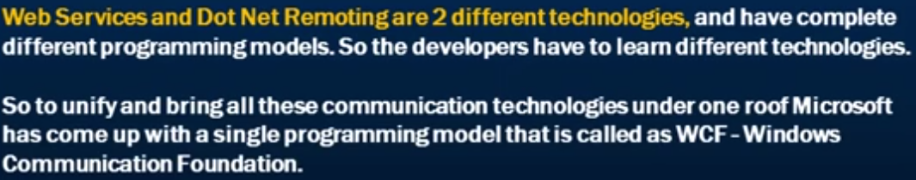

WCF save us from learning two different technologies and also from implementing the same code again and again. Same code can be used with WCF for all interoperability of message formats and protocols. In WCF, for the above example of the 2 clients, we just need to configure two end points and that’s it. In the endpoint configuration, we can specify the message format and protocols that we want to use.

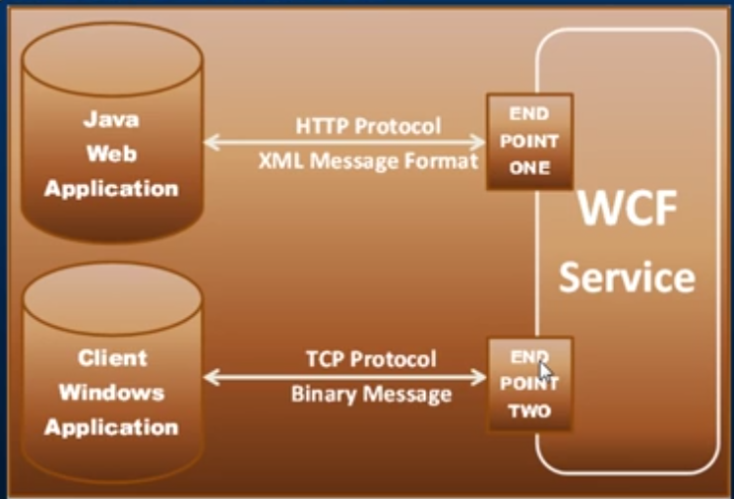

Now if someone comes with a TCP Protocol and XML message format, all we need to do is to create another service endpoint for them and voila we are done.

## Creating a WCF Service:

Create a Class Library Project (.NET framework) in Visual Studio and then Add a WCF Service to that project. Once you add the WCF Service to the project, you will notice that it has added a System.ServiceModel dll to the References. It is the core to WCF. All the attributes and classes that we will use are present in this assembly.

Further, it will also add to class files. One is the interface and another is its implementation. It decorates the interface with the **ServiceContract** attribute. Just by adding this attribute to the interface, it turns the interface into a WCF service. Decorating a method of the interface with the **OperationContract** attribute, we are making this method available as part of this service to the client.

Implement all the methods of the interface as usual and we are done with the WCF service creation.

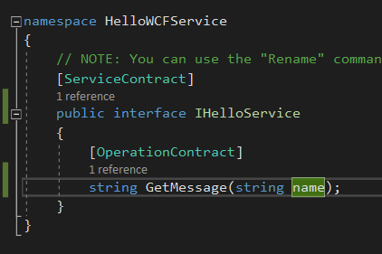

Implementation of the interface.

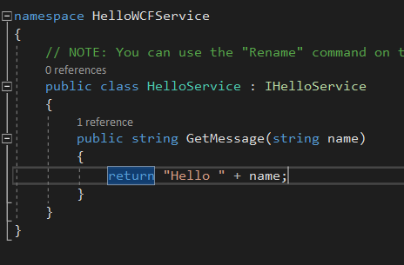

Now let’s host this WCF service with the use of console application for making things simple. WCF service has a lot of hosting options.

1. Using Windows Forms applications.
2. Windows service
3. IIS

For our purpose for now, let’s just add a console application to the solution with name HelloWCFServiceHost. To host this service via console application, we need to add its reference to the console application project just added.

So, we are going to add the System.ServiveModel and HelloWCFService reference to our console project.

Now comes the most important part. We need to add the endpoint configuration. We are going to do that within the host i.e. in our console application. Add a application configuration file (app.config) to our console project. Now to this app.config we will add our endpoint. An endpoint needs to have 3 things.

1. Address – should be the address of the client application which will consume this WCF service. *The address is the relative address.*
2. Binding – this is the most important thing as it tells the message and the protocol for the endpoint.

To look at what all the bindings are available in .NET, under the system.servicemodel tag just open the bindings tag and under the binding tag, as soon as you open the angle bracket, you can see all the bindings that are available.

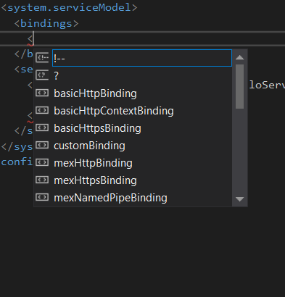

1. Contract – it is the name of the interface of the WCF service.

We need to expose another endpoint here apart from the 2 endpoints that we have created for the example we took in the starting. This new endpoint is basically for exchanging metadata. To consume a web service, the client specifies the url of the WSDL document. Even in WCF, we use the WSDL file to exchange Metadata. So we need to allow our service to exchange metadata and for that we are going to add the 3rd endpoint.

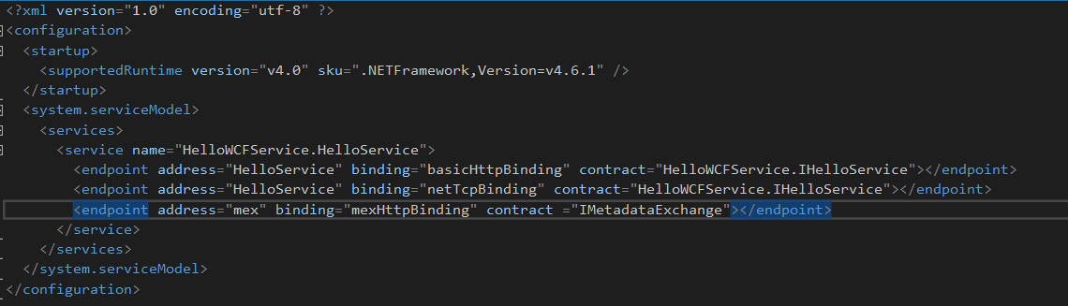

This 3rd endpoint is the one that the users will hit to get the WSDL document.

Let’s now define a base address as the address in the endpoint is the relative address.

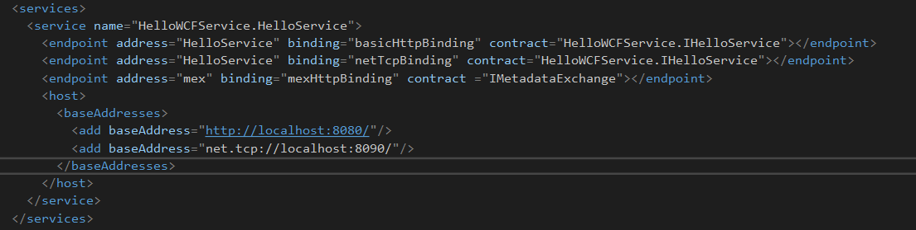

So to access the WSDL document and invoking the service the address becomes like <http://localhost:8080/HelloService> which is the combination of the base address and the relative address in the end point.

*Now we need to specify the service behaviors. The basic purpose of the behavior is to allow the service to exchange metadata. Once the behavior is specified, we need to add this information to the service behavior configuration.*

Final configuration file looks like the below.

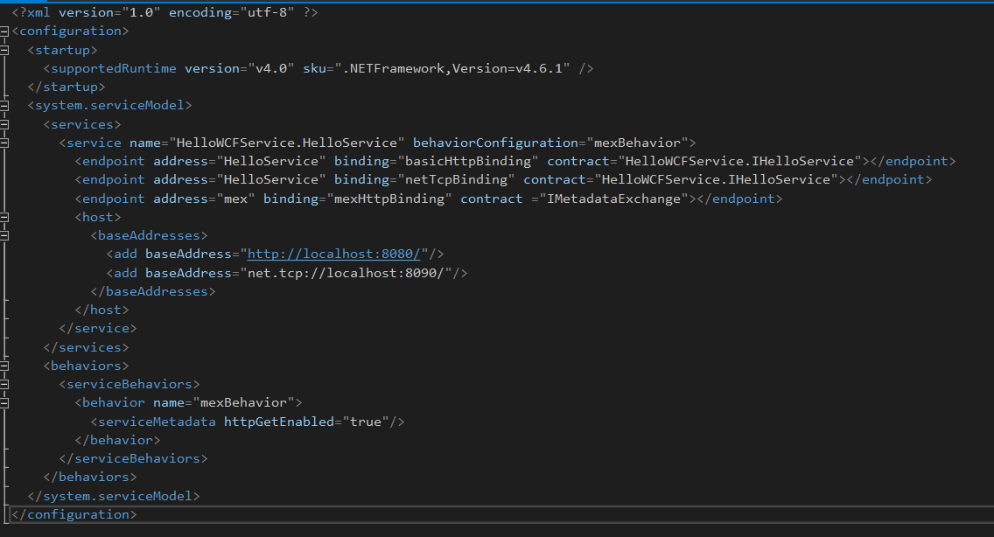

Set the Service host i.e. the console project as our startup project. Finally, in the Program.cs file of the console project, open the WCF service connection and run the solution.

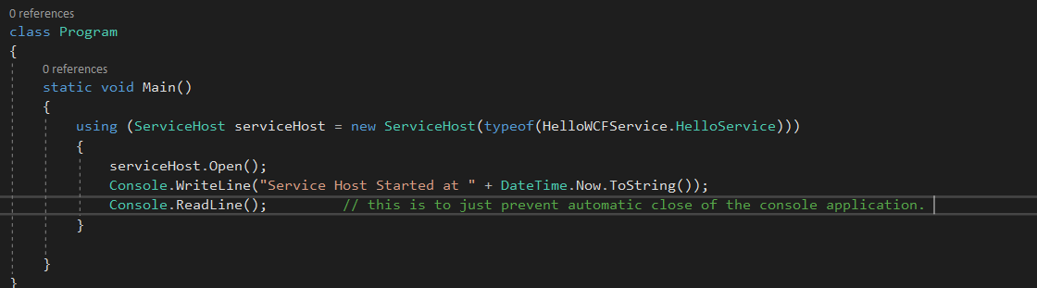

***Remember that we have defined the 3rd endpoint for metadata exchange with the name “mex”. So any client application goes to the url comprising of the base address followed by the mex (http://localhost:8080/mex) , they can get the WSDL document associated with the WCF service.*** *This WSDL document is used by the client to generate the proxy classes using which we can communicate to the WCF service.*

## Creating a client application and consuming the WCF Service:

Let’s create an empty web application named HelloWebClient. Right-click references older and click on add service reference.

Specify the address of the wsdl document. In our case, it will be <http://localhost:8080/> and click GO.

Select the service and provide a meaningful namespace and click OK.

This will automatically add the serviceModel dll reference to the references folder. It will also generate a proxy classes for us and one of the proxy Class should be HelloServiceClient if the namespace name is HelloService. Also, in the web.config file a lot of serviceModel configuration is generated and added.

HelloService.HeloServiceClient client = new HelloServiceClient(HelloService_BasicHttpBiding);

Label1.Text = Client.GetMessage(TextBox1.Text);

And this is it.

## WCF Service implementing multiple service contracts:

We know now that an interface in a WCF service act as a service contract. So we can have multiple interfaces decorated with the ServiceContract attribute and their exposed methods decorated with OperationContract Attribute.

We use http protocol for services that we are going to make public as it will be available to all the users behind the firewall and also for users outside the firewall.

We use TCP protocol for services that we want to be available behind the firewall so that it is available to only the users within the company.

Finally, our class will implement both the interface and configure them in different endpoints as before in the app.config file.

## How to make changes to a WCF service without breaking the existing clients:

If you change the name of the interface directly and make all those changes in the implementing class and app.config etc then after running the service, the existing clients will break because the existing clients will not know the name of the changed service contract (which is the interface) and throw an error. Changing the name of the interface is a breaking change. The breaking message will say “mismatch in the endpoint mismatcher”.

To avoid this breaking change, we can change the name of the interface throught the serviceContract attribute.

[ServiceContract(Name = IHelloService)]

Public interface IHelloServiceChanged {

}

We here changed the name of the interface in our WCF service everywhere directly but we decorated it wil the original name in the attribute. This resolves the breaking change as the decorated name will be used by the client when consuming the service.

Let’s now understand how name parameter in the decorator attribute managed to do so. For this we need to understand the WSDL document that the WCF service makes available for the clients to generate their proxy classes.

WSDL document has a port type tag that has the name of our service.

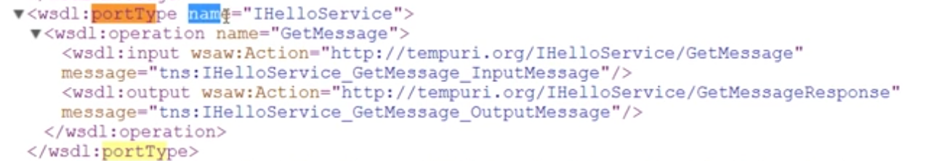

When you change the name of the service interface and no decorator name parameter is present, the port type name has the changed name in the WSDL document that is available to the client.

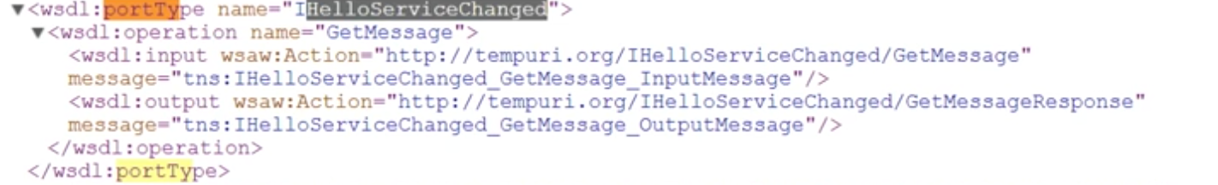

If we do not set the name of the service interface explicitly by using the name parameter in the decorator, it will take the name of the interface as the name.

Now since the client has already generated the proxy classes before the change, it will have the old name which now not exists in the WSDL document after change and thus breaks the client. **This I need to check personally. It is just a logical explanation by me that post changing the name of the interface, if we regenerate the service proxy by adding the service reference like before, it will work.**

But doing so will force us to make changes to the client as well. If we want to change the WCF service without breaking the existing clients, we need to decorate the interface attribute and pass the name parameter with the old name.

## WCF DataContract and DataMember:

With respect to WCF, Serialization is the process of converting an object into XML representation. Reconstructing the same object from XML is called Deserialization. By default, WCF uses the DataContractSErializer.

Let’s create an EmployeeWCF Service which we will use for getting the employee details and saving a new employee to the database. This service will also contain an employee model class which contains the properties of the employee table as its members.

Now, it is interesting to note here that we will not be adding any Decorator to the employee model class and the process of serialization and de-serialization works just fine. When we call the GetEmpoyee method of the Service, it converts the employee object to the XML format through the process of serialization.

When we use the SaveEmployee method, it converts the XML format employee data to the Employee Object and passes the object to the method as parameter through the process of de-serialization.

WCF uses the dataContract Serializer by default, so even if our employee model class is not yet decorated with anything, it works just fine.

With .NET 3.5 SP1 and above, we don’t explicitly have to use DataContract or DataMember attributes. The DataContract serializer will serialize all public properties of your complex type like Employee in an alphabetical order. By default, private fields and properties are not serialized. This can be verified through the WSDL document.

WSDL document will not have the employee object but we can see the schema location in this document under types. We can also see the schemalocation of the employee service data contract as the last.

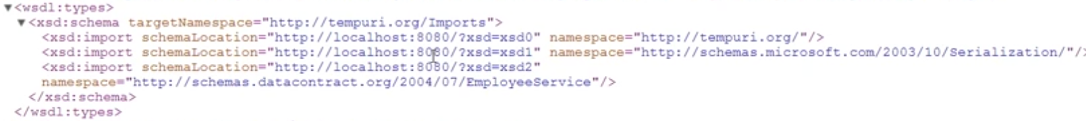

If we copy and open the url of the schema location, we can see the schema type as employee and its members as element present in alphabetical order.

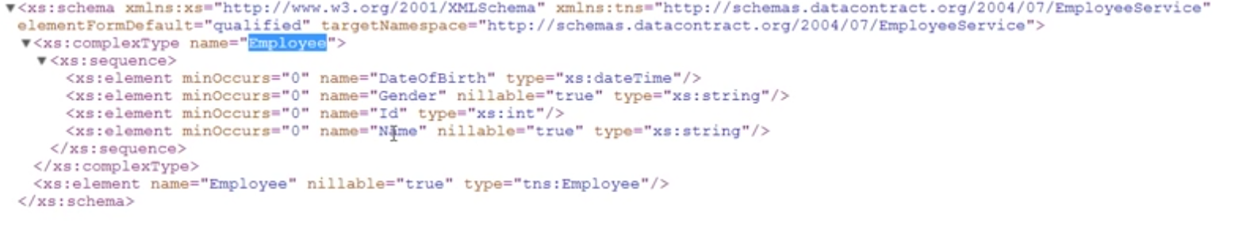

*If we decorate a complex type with the Serializable attribute, the DataContractSErializer serializes all fields. With [Serializable] attribute, we don’t have explicit control on what fields to include and exclude in the serialized data. It serializes all the fields whether public or private and not the properties.*

*If we decorate the complex type with the [DataContract] attribute, the DataContractSErializer serializes the fields marked with the DataMember attribute. the fields that are not marked with the DataMember Attribute are excluded from serialization. The [DataMember] attribute can be applied either on the private fields or public properties.*

*In WCF, the most common way of serialization is to mark the type with the DataContract attribute and mark each member that needs to be serialized with the DataMember attribute. Using DataCOntract Attribute, you can define the XML namespace for your data.*

*Using DataMember Attribute, you can*

1. *Define name, order and whether if a property or field is required*
2. *Also, serialize private fields and properties.*

*We can also control the order in which the properties are getting serialized. We can define our own order instead of the alphabetical order serialization by default.* That’s the beauty of using the DataCOntract Atttribute.

## Known Type attribute in WCF:

If we have classes related by inheritance, the wcf service generally accepts and returns the base type. If you except the service to accept and return inherited types, then use the KnownType attribute.

The Known Type attribute is added to the model class Employee in our example.

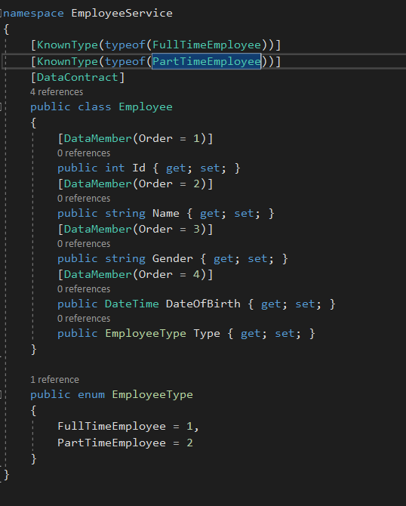

This now ensures that we can accept and return an object of the inherited types also.

When you look at the WSDL document of the url related to the employeeService, you can see the complex types present in the document which refers to the FullTImeEmployee and the PartTimeEmployee.

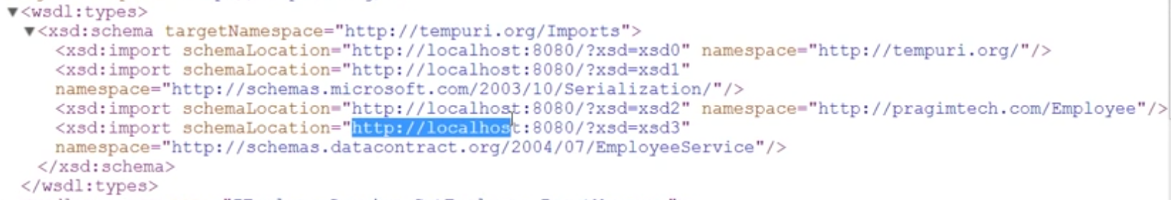

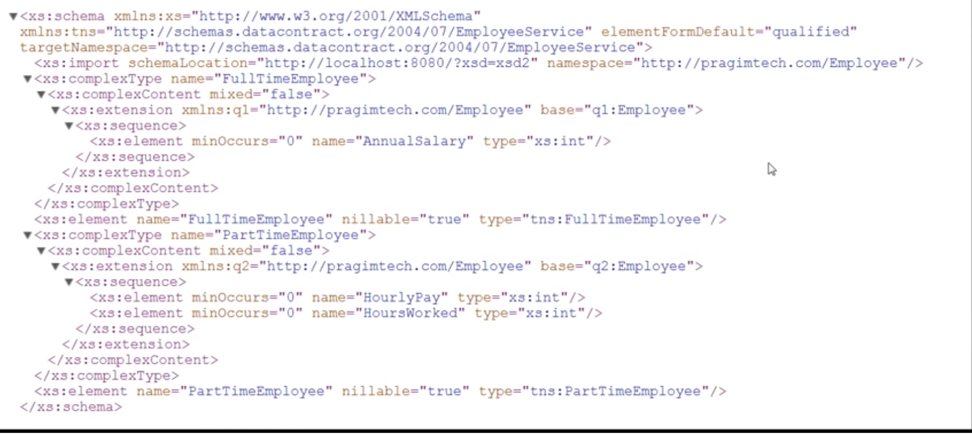

Carefully notice that in the WSDL document of the EmployeeService we do not have anything about the enum’s which are simple type. This is because we have not decorated the EmployeeTYpe property of the employee model class with the DataMember attribute. Once you decorate that, you can see the WSDL document change.

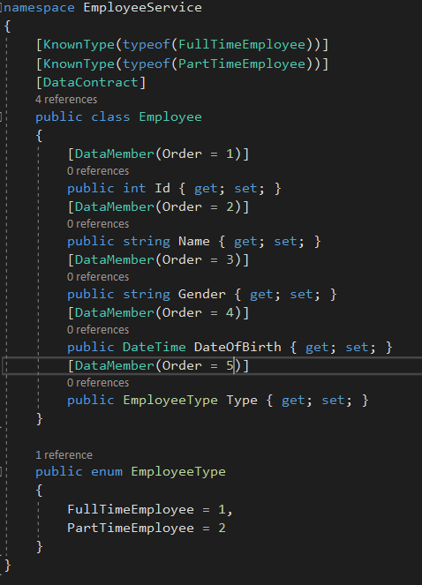

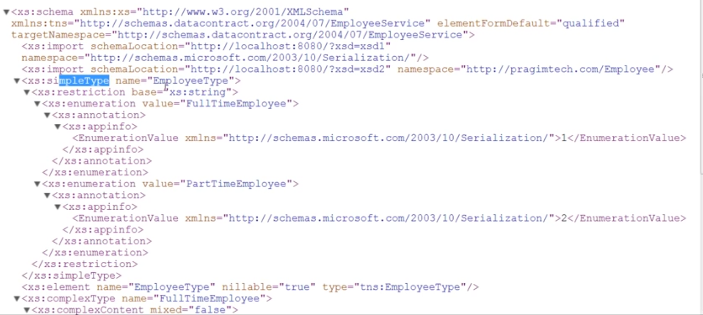

The PartTimeEmployee and the FullTypeEmployee information in the WSDDL document is because of the decoration of the model class with the Known Type attribute. if we comment or remove the KnownTYpe decorator attribute, WSDL document will not have the information about the inherited classes and we will not be able to accept or return the inherited types.

## Different ways of associating known types in WCF

There are 4 different ways to associate known types.

1. Use known type attribute on the base type – this option is global that is all service contracts and all operation contracts will respect the known types. This is the option use in above topic.

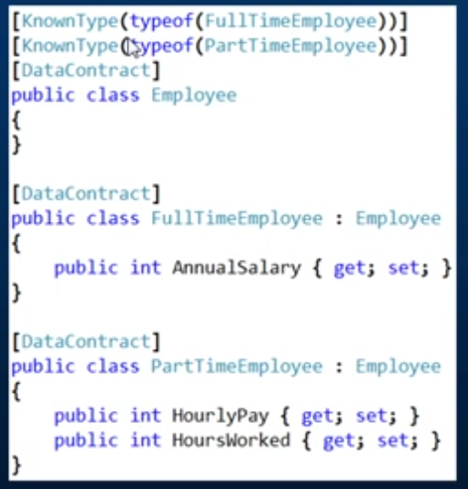

1. Apply ServiceKnownType attribute on the service contract – With this option the known types are respected by all operation contracts within this service contract only.

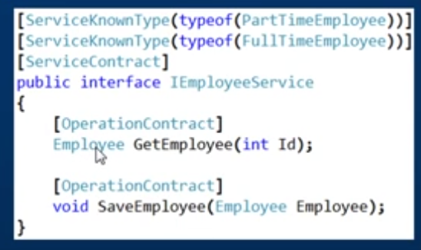

Now only this service only going to allow part time employee and full time employee types as known types of the Employee base class.

If you have another service and you want that service to also accept and return the full and part time employee derived types then you need to decorate that service also with the ServiceKnownType attribute. This gives us more granular control.

1. Applying Service known type attribute on specific operation contract – this gives us even more granular control. Only the operation contract that are decorated with the ServiceKnownType attribute respect the derived known types.

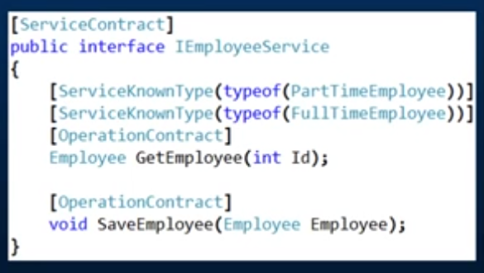

With this only the methods that are decorated can accept and return the derived types and non decorated methods will throw an error if tried to accept or return the derived types.

1. Specify the known types in the configuration file – this is equivalent to applying the known type attribute on the base type as it is also applicable globally. All service contracts and operation contracts respect the known types.

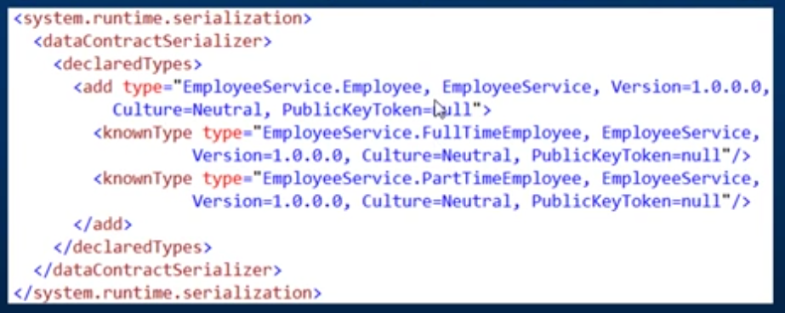

## Tracing and Message Logging

Use the Microsoft Service Configuration Editor tool to enable tracing and message logging in WCF. This can be done either on the client or the WCF Service.

1. Enabling it on the client application: Just right-click the Web.Config file and select Edit WCF Configuration option. If you do not find this as an option then go to Tools-> Select WCF Service Configuration Editor. It will not open the config file by default. Go to file and then open the config file of your project.

Go to Diagnostics and turn on the following options for enabling tracing and message logging.

1. Log Auto Flush
2. Message Logging – this will add a file in your project with name similar to web_messages.svclog
3. Tracing – this will also create a file with name similar to web_tracing.svclog in your project path.

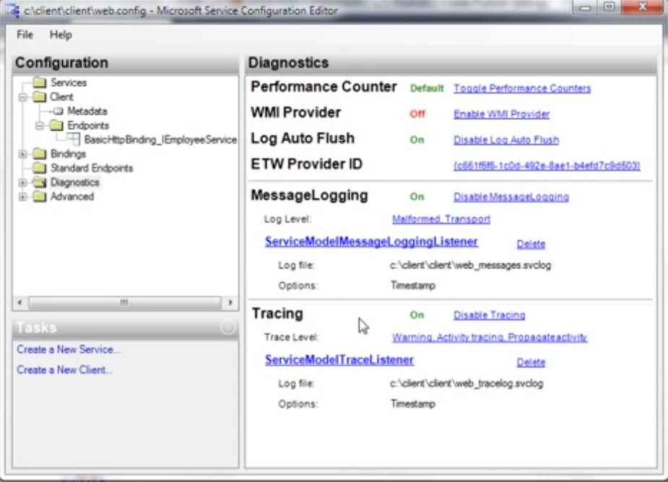

Also in the left pane, expand the diagnostics and select the Message logging. Turn the Log Entire Message property to True. By default the value is set to false.

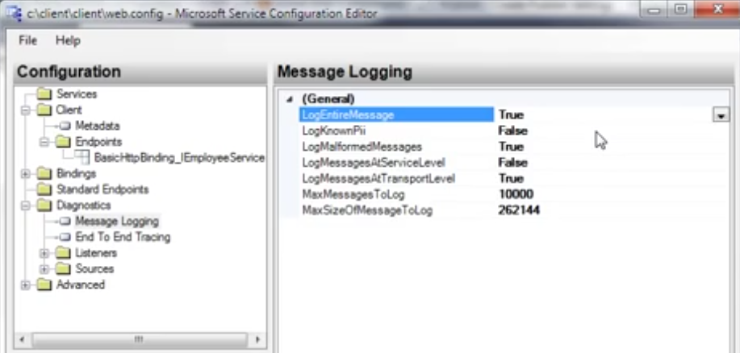

This adds the diagnostics settings to the web.config file to enable the tracing and message logging under sys.diagnostics tag under configuration root tag.

Use the Microsoft Service Trace viewer tool to open the *.svclog log files.

1. To enable the tracing and message logging on the WCF Service application repeat the same steps.

**A look at the web_messages.svclog file**

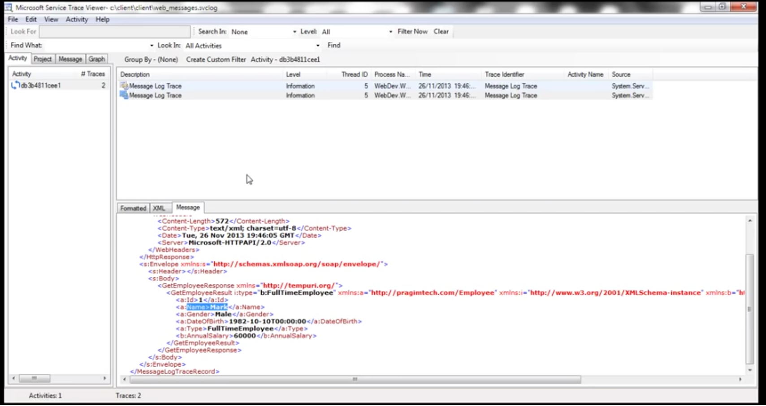

## Message Contract in WCF

With Data Contracts we have very limited control over the SOAP XML requests and response messages that are generated. Use Message Contracts to get full access over the generated SOAP XML messages.

Few examples of when message contracts can be handy.

1. Include some custom data in the SOAP header. In general, SOAP headers are used to pass user credentials, license keys, session keys etc.
2. Change the name of the wrapper element in the SOAP message or to remove it altogether.

*NOTE: In general, use message contract only if there is a reason to tweak the structure of the SOAP XML message.*

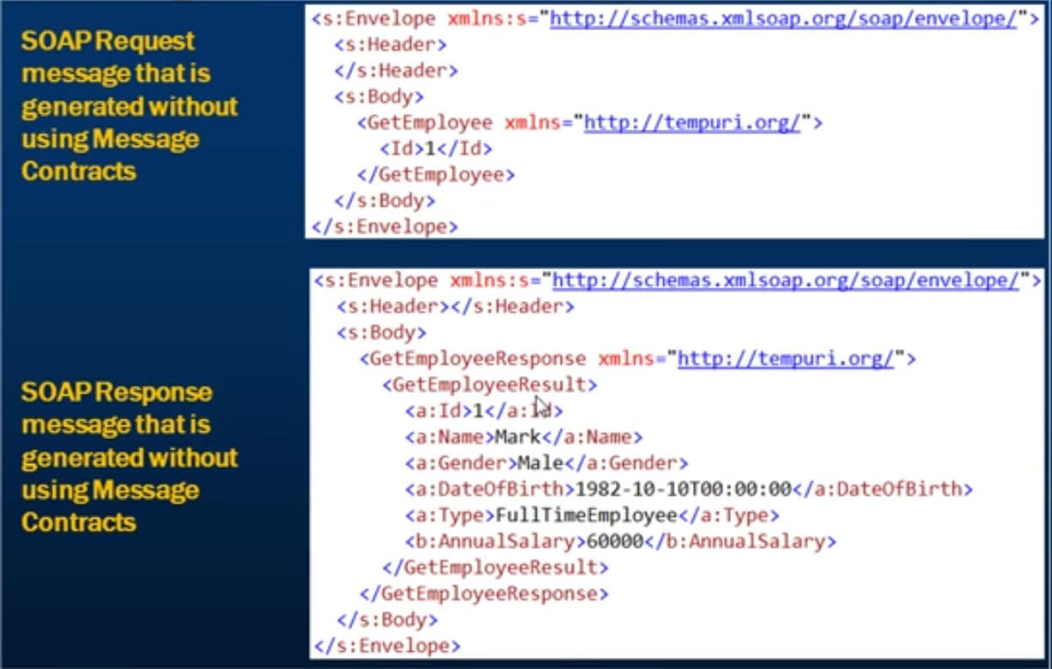

Notice here that we have a soap envelop and within it we have soap header and soap body. Now within the soap body of the get request, we have an element called GetEmployee. This element is called the **Wrapper Element.** The wrapper element name is the same as the name of the operation contract. So by default, the wrapper element with in the soap request message is getting the name of the operation contract. Id element is nothing but the name of the parameter that the method expects.

Similar to the request message, the soap response message also has the soap envelop and within that the soap header and the soap body. Here GetEmployeeResponse is the Wrapper element where GetEmployee is the name of the operation contract and “Response” is appended at the end of it. Within this we have another wrapper element GetEmployeeResult similar as above in “Result” appended to the GetEmployee operation contract. And with in this we have our parameters corresponding to the rest of the properties.

*If we want to tweak this request and response messages, we will make the use of message contract.* Below imae shows how we want to tweak the messages.

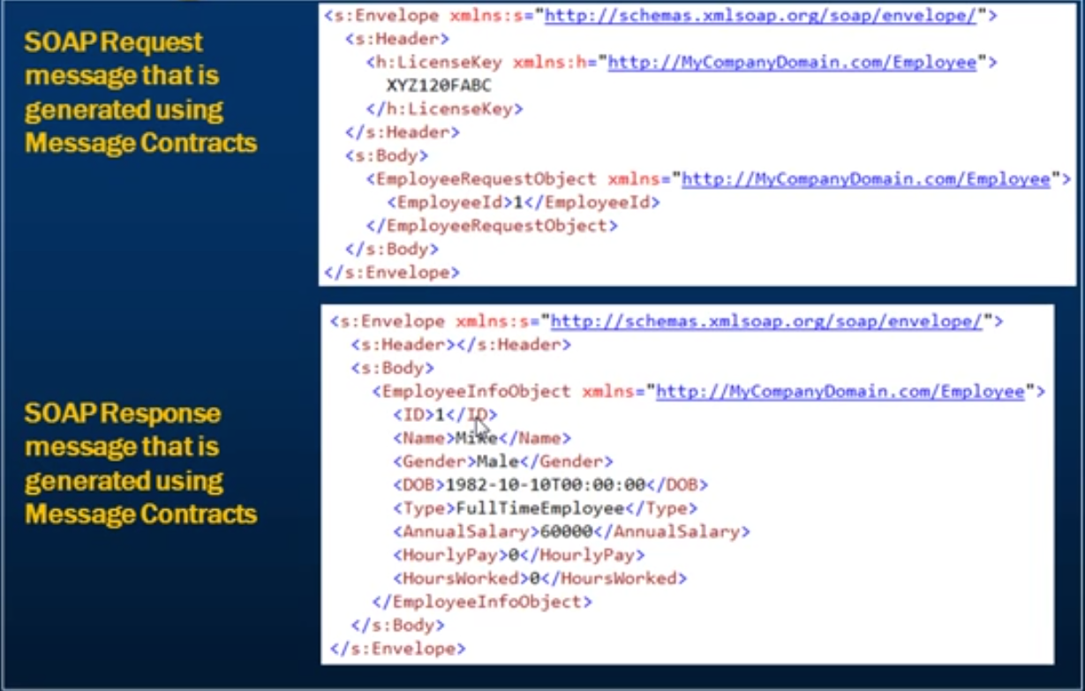

To achieve this, we will be creating few classes as below apart from the existing Employee, FullTimeEmployee and PartTimeEmployee classes.

1. EmployeeRequest Class

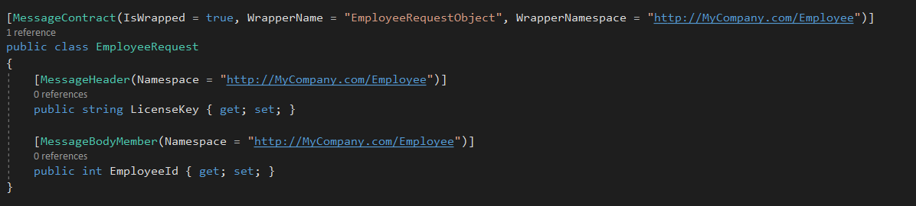

1. EmployeeInfo Class

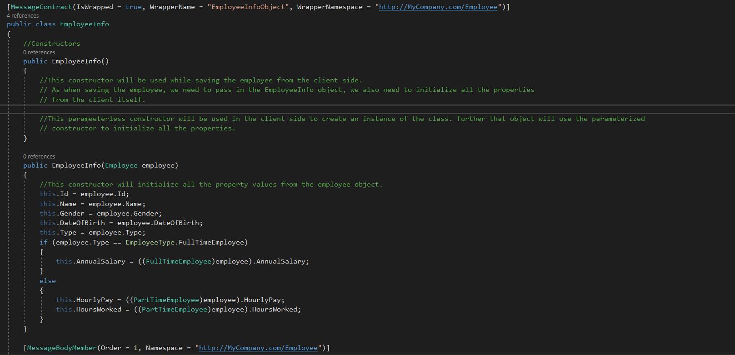

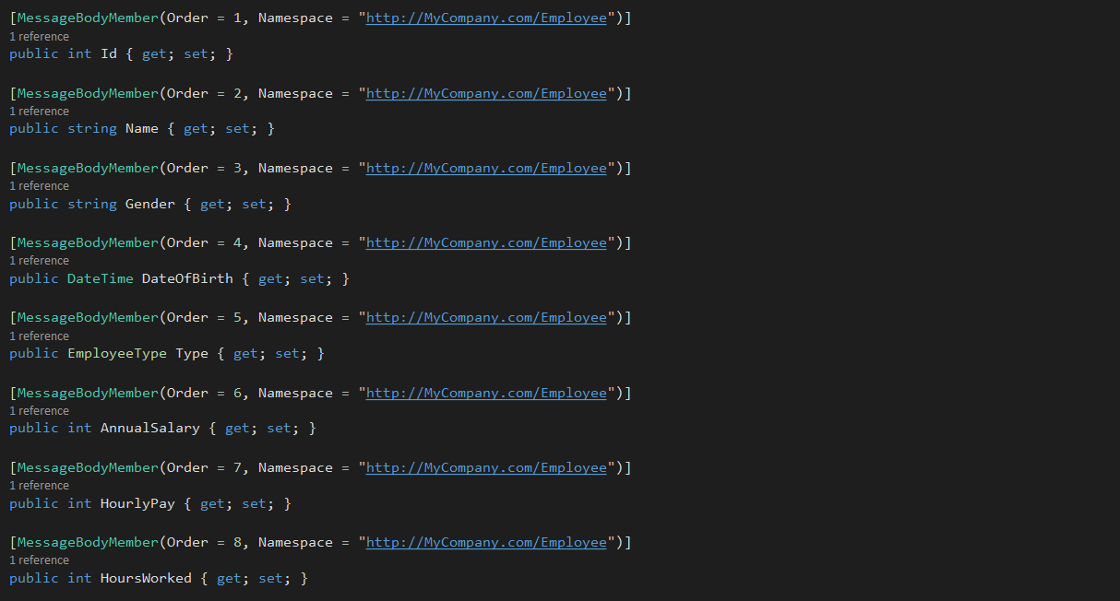

IEmployeeService SErviceContract also needs to be changed along with its implementation

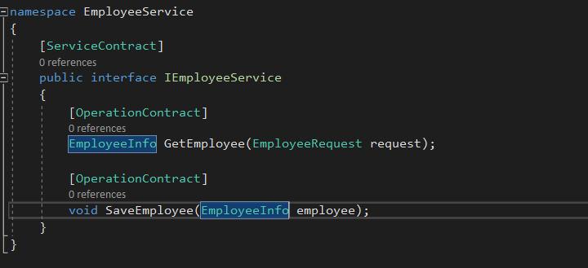

Service logs after implementing the wrapper classes.

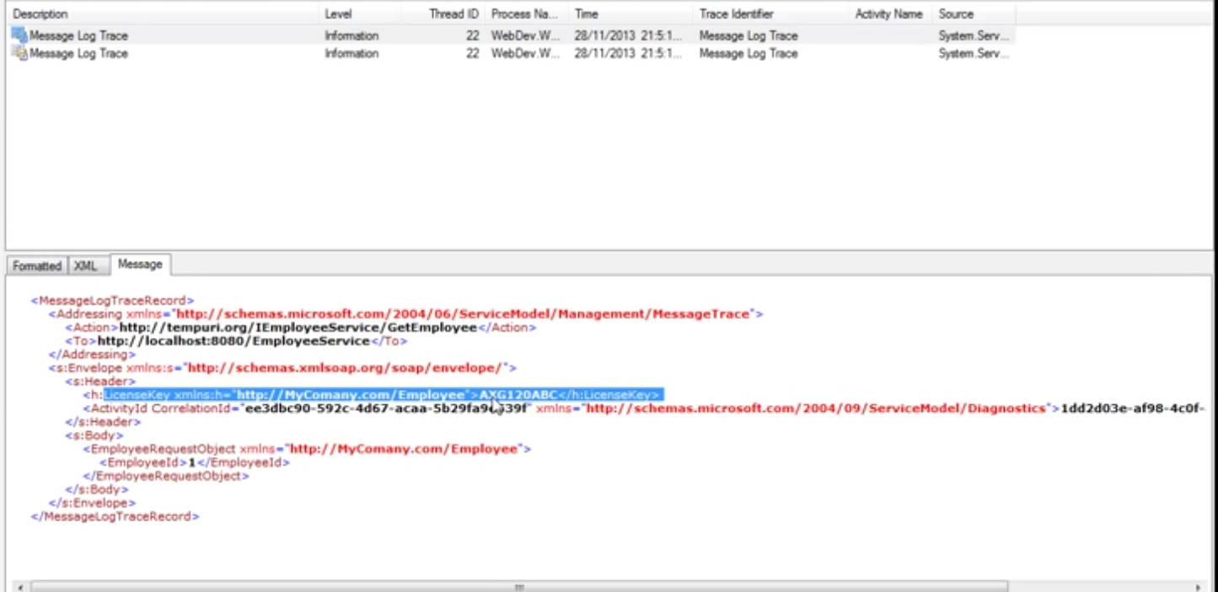

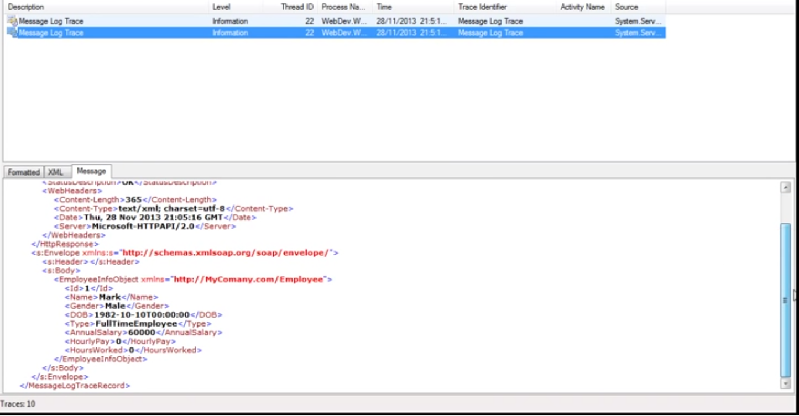

So, in summary,

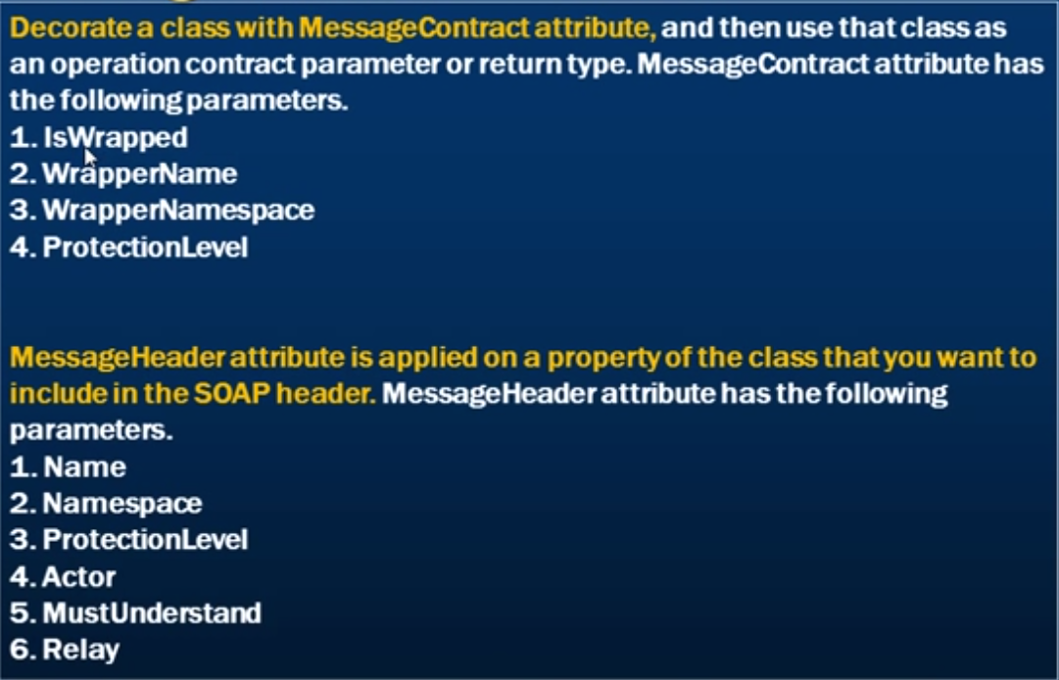

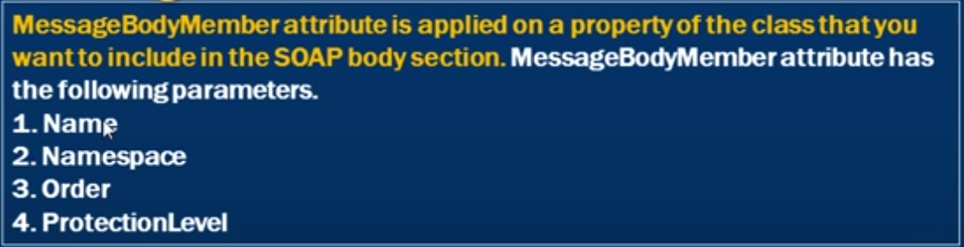

## Difference between Data Contract and Message Contract

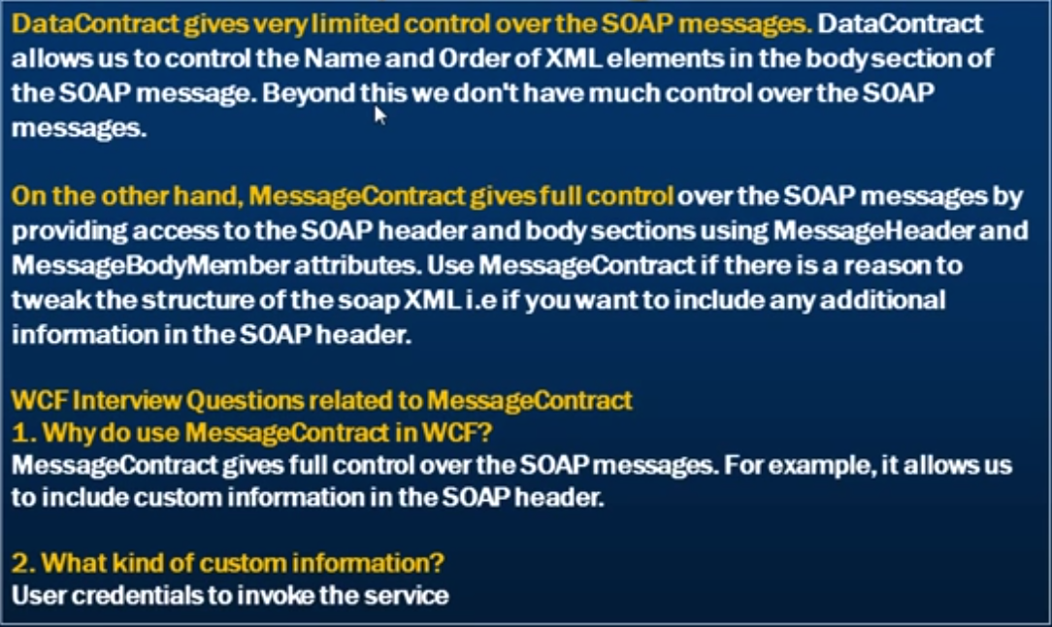

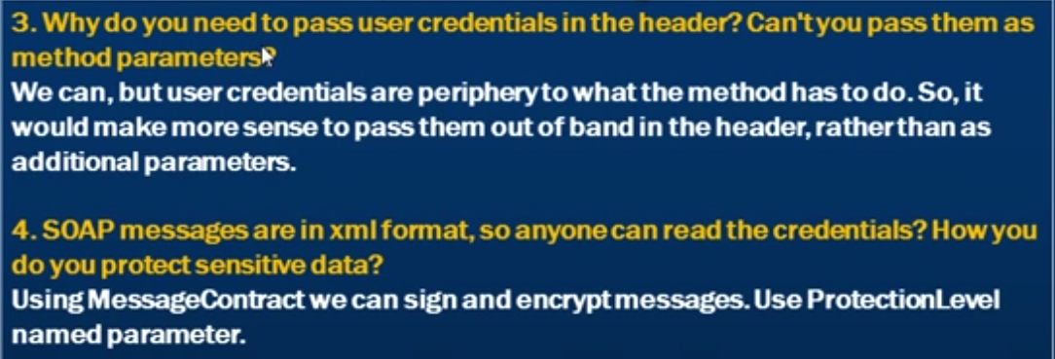

## Backward compatible WCF contract changes

This is about making changes to the WCF Service in such a way which does not breaks the existing clients.

In general, WCF contracts are version tolerant by default. The Data Contract Serializer which is the default engine for serialization in WCF allows missing, non-required data and ignores any superfluous data for service contracts, data contracts and message contracts.

For a full list of changes and the impact that they can have on the existing clients visit <http://msdn.microsoft.com/en-us/library/ff384251.aspx>

Changes that can be made to a service contract

1. Adding a new parameter to an existing operation will not break the existing client. This is because, the newly added parameters if not passed gets initialized to its default value. So the existing clients that has no idea of the newly added parameter will not send any value for it.
2. Removing an existing parameter also does not break the existing clients. This is because the extra parameters passed by the clients gets ignored by the service.
3. Adding a new operation contract will also not break the existing clients.
4. Removing the existing operation contract will affect the existing client. If they tries to call the removed operation contract, they will get an exception.

Changes that can be made to a Data Contract

1. Add new non-required members: Clients unaffected. Missing values are initialized to defaults.
2. Add new required members: An exception is thrown for the missing value.
3. Remove non-required members: Data lost at service. No exceptions. Not a breaking change for existing clients.
4. Remove required members: An exception is thrown when client receives responses from the service with missing values.
5. Modify existing member data types: if they are compatible, no exceptions but may receive unexpected results.

## ExtensionDataObject in WCF

Let’s say now that we have removed the non-required Gender from the Employee model class in the WCF Service. This will not break the existing clients as the extra information for the Gender from the client will be lost in the Service. What happens is, the client converts the Employee object into xml which will have the value of the Gender passed before sending it to the Service. Service deserializes the XML and builds an Employee object out of the xml passed. The Extra information of Gender in the xml is ignored by the service.

What if we want to preserve the data and return it back to client. This is where **ExtensionDataObject** comes handy.

This can be done by implementing IExtensibleDataObjct interface. We need to inherit our Employee model class with this interface. This interface contains one property called ExtensionData which is of the type ExtensionDataObject. We will implement this property in our model class.

With this, if there are any unknown element in the XML that is received by the service, those unknown data will be stored in ExtensionDataObject. When we need to pass the data to the client, we need to serialize the data into XML. During that serialization process we take the unknown element from this ExtensionDataObject and put them in an XML format in a way that we receive them when the service was initially called.

*We can use IEXtensibleDataObject at the client side also.*

This only work for the existing clients. For the new clients, the service proxy generated will not have gender property constructed and they will not pass any value for the Gender field to the service.

***So after implementing the EntensionData property of the IExtensibleDataObject in the Employee Model class (the property will be an auto implemented property i.e. getter and setter will not be implemented by user.), the Implementation class of the IEmployeeService needs to be decorated with ServiceBehavior attribute with InstanceContextMode value of Single.***

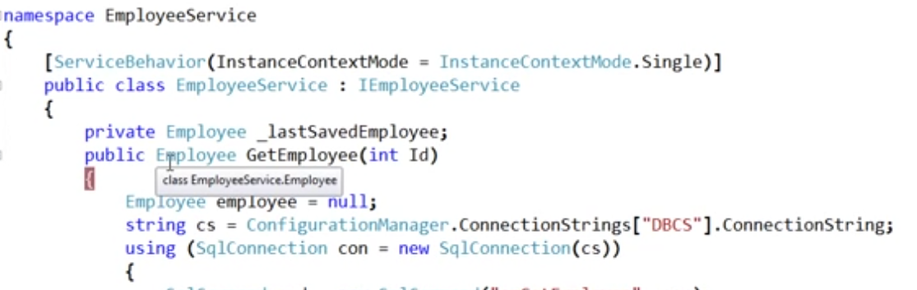

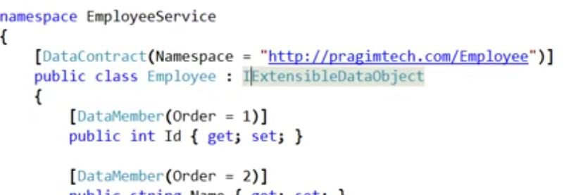

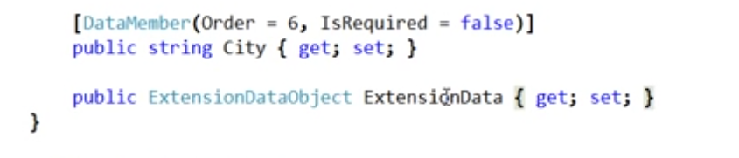

## Risks of implementing IExtensibleDataObject:

The downside of implementing the IExtensibleDataObhect interface is the risk of denial of Service Attack. Since, the unknown data is stored in memory, the attacker may flood the server with requests that contain large number of unknown elements which can lead to System out of memory and Denial of Service (DoS).

One way to remove the risk is by removing the implementation of the IextensibleDataObject from all the Data Contracts. This can become tedious in a large application where application can have a large number of Data Contracts.

Another way to remove it is by disabling it through Service Behavior Configuration.

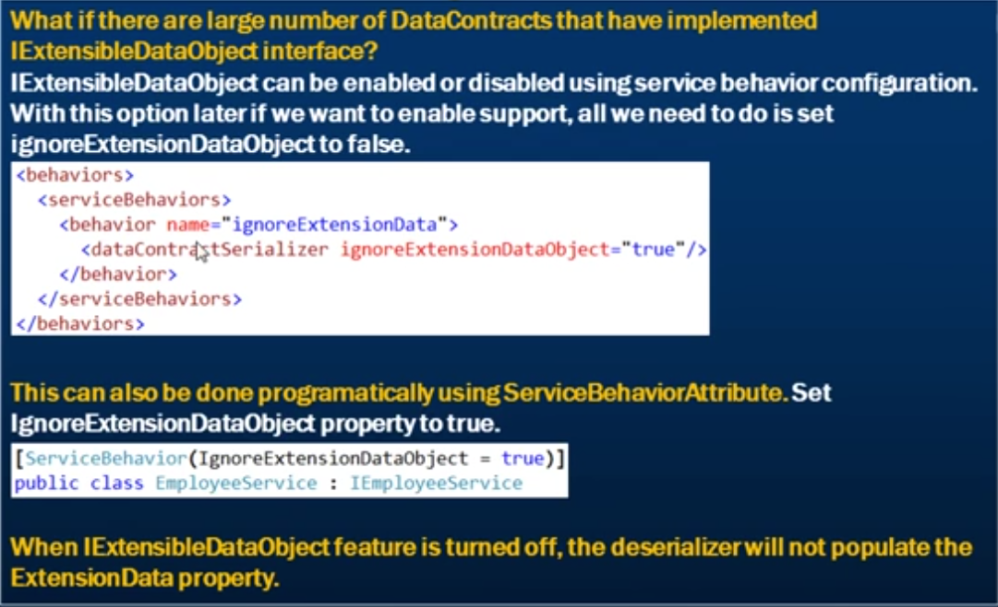

# Exceptions and Faults in WCF

## Exception Handling in WCF

When you get an exception in the WCF service, on the client side application which is consuming the service, we don’t get the .Net exception but instead get a SOAP Fault exception

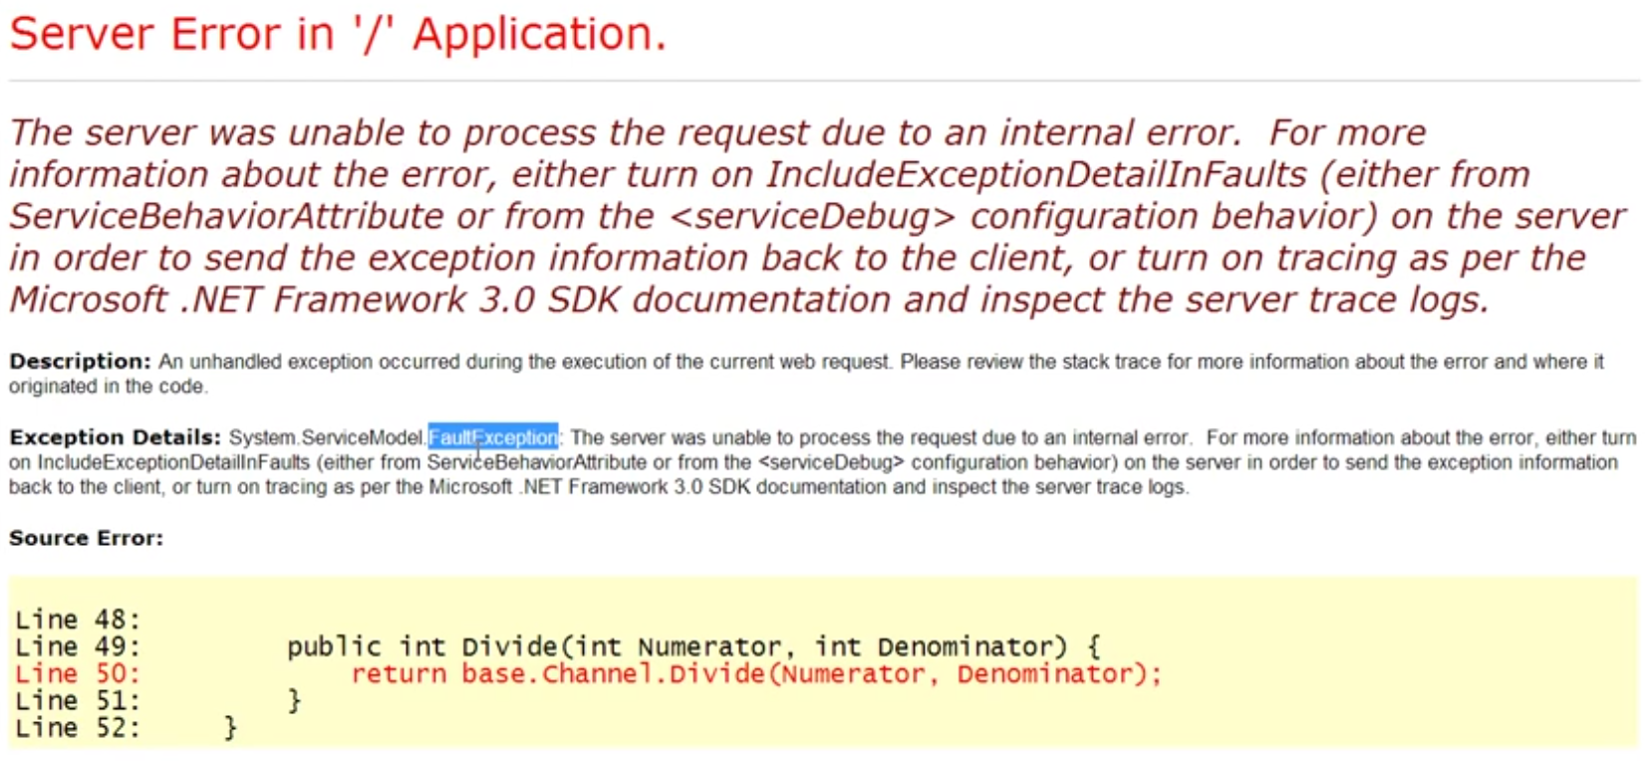

The .Net exception is not sent to the client. The exception itself is an object which needs to be serialized into Xml before sending it to the client application. The exception is converted into something called Soap fault which is in Xml and is returned to the client application.

By default when there is an exception in the WCF Service, the exception details are not included in the Fault Exception that is returned to the client. This is done because of the security reasons.

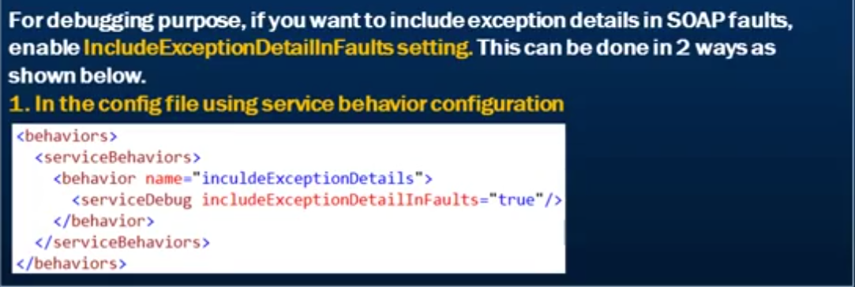

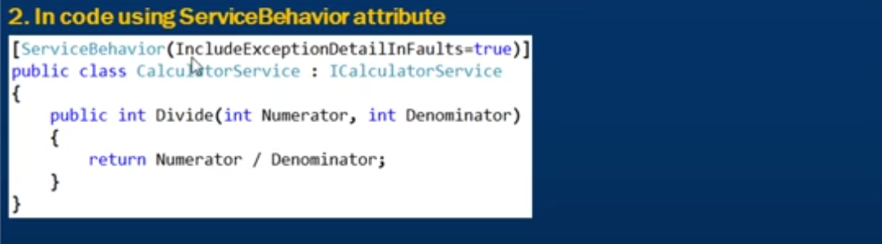

## SOAP Faults in WCF

SOAP faults are in Xml format and hence are platform independent. A typical Soap fault contains

1. Fault Code
2. Fault Reason: In SOAP 1.1, fault reason is called fault string.
3. Detail elements etc.

The detail element can be used to include any custom Xml

SOAP Faults are formatted based on SOAP 1.1 or SOAP 1.2 specifications. SOAP format depends on the binding. BasicHttpBinding uses SOAP 1.1 whereas the other built in WCF bindings uses SOAP 1.2

To view soap fault messages, we need to enable message logging in WCF. Right-click app.config -> select Edit WCF configuration -> Under Disgnostics -> Enable Log Auto Flush, Message Logging

Under Diagnostics -> Under Message Logging -> Set LogEntireMessage to True.

Set includeExceptionDetailsInFaults to false which we have enabled to true for the debugging purpose to see the .Net exceptions in the fault messages.

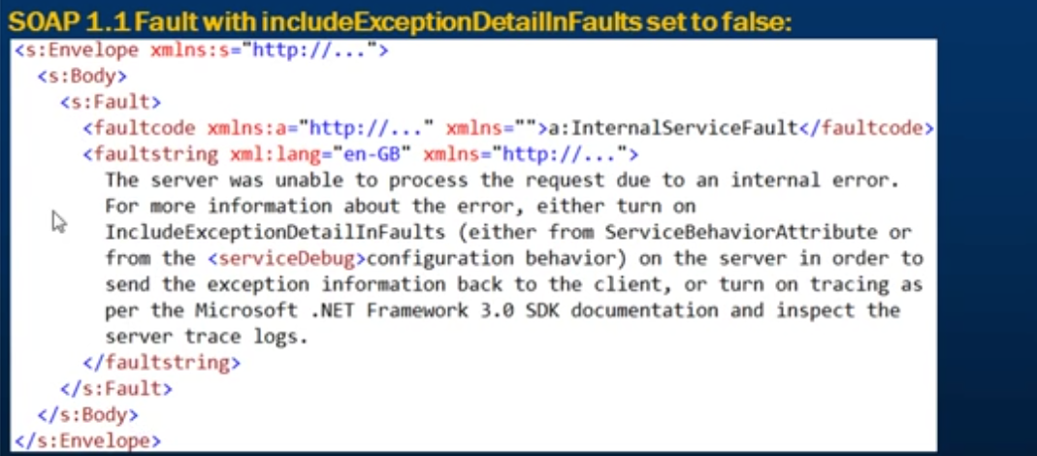

Notice that we do not have the detail element present in the SOAP fault. This is because we have turned off the includeExceptionDetailsInFault in the configuration.

Now let turn it on in the configuration.

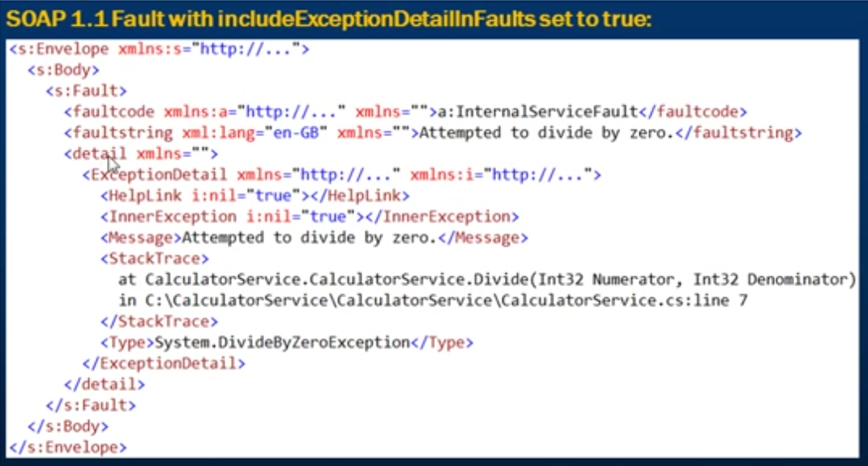

To view SOAP 1.2 fault message, set binding to wsHttpBinding.

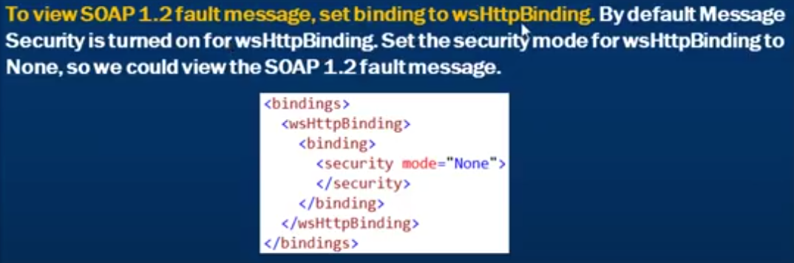

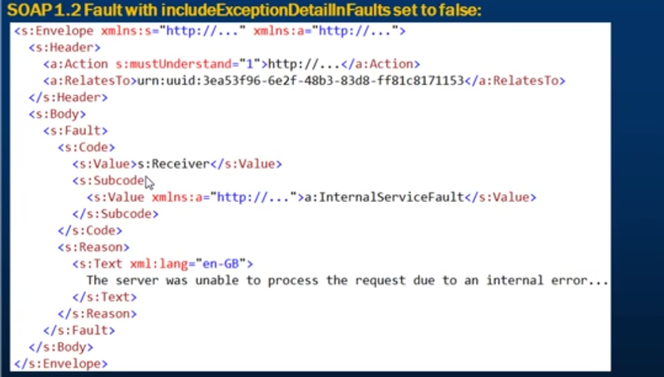

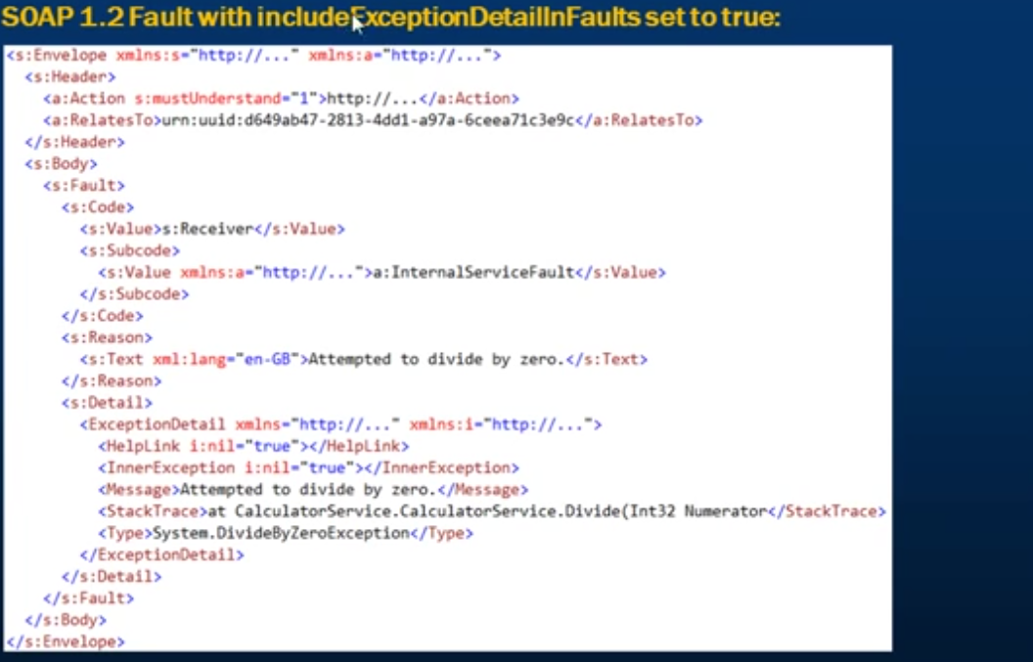

## Unhandled Exceptions in WCF

An unhandled exception in the WCF Service, will cause the communication channel to fault and the session will be lost. Once the communication channel is in faulted state, we cannot use the same instance of the proxy class anymore. We will have to create a new instance of the proxy class.

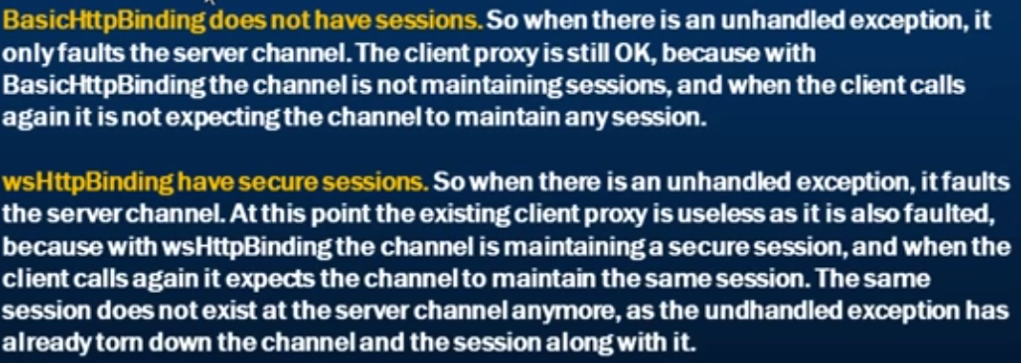

## Throwing fault exceptions from a WCF Service

A WCF Service should be throwing a FaultException or FaultException<T> instead of .Net Exceptions. This is because of the below 2 reasons.

1. An Unhandled .NET Exception will cause the channel between the client and the server to fault. Once the channel is in faulted state, we cannot use the client proxy anymore. We will have to recreate the proxy. 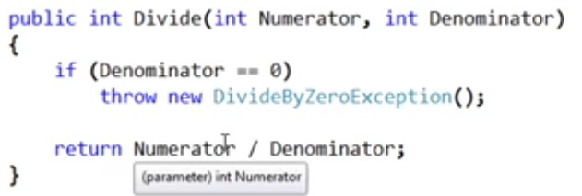

Even handling the exception and throwing the .NET exception in the WCF Service will result in the same.

On the other hand, faultedExceptions will not cause the communication channel to fault.

1. As .NET Exceptions are platform specific, they can only be understood by a client that is also .NET. if you want your WCF Service to be interoperable, then the service should be throwing Faulted Exceptions.

The correct way to handle exceptions in the WCF Service is through a FaultException

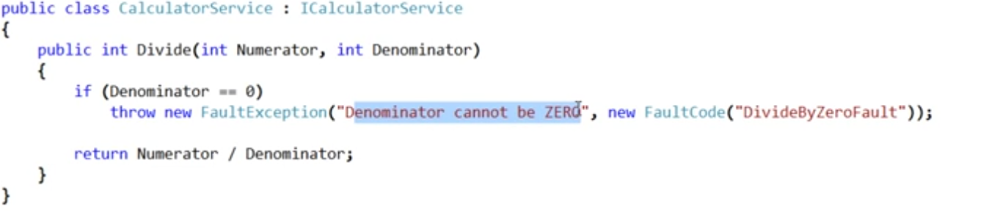

## Creating and throwing strongly typed SOAP Faults

Instead of throwing a generic SOAP fault, we can create strongly typed SOAP faults and throw them. Creating our own strongly typed SOAP fault allows us to include any additional custom information about the exception that has occurred.

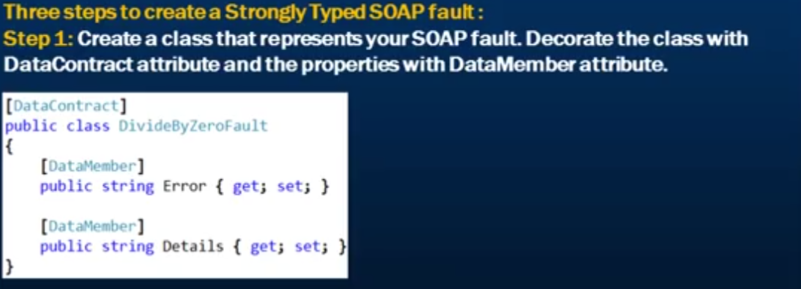

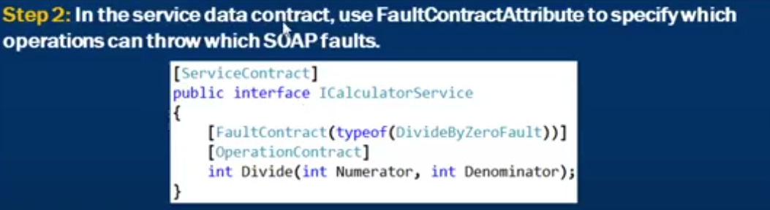

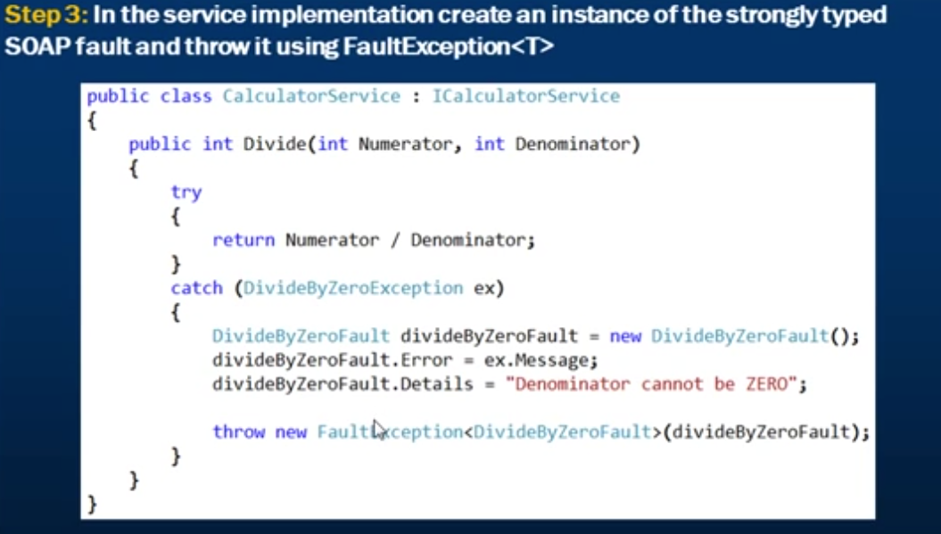

## Centralized Exception Handing in WCF

This is done by implementing IErrorHandler interface. There are 3 steps to centralize exception handling in WCF.

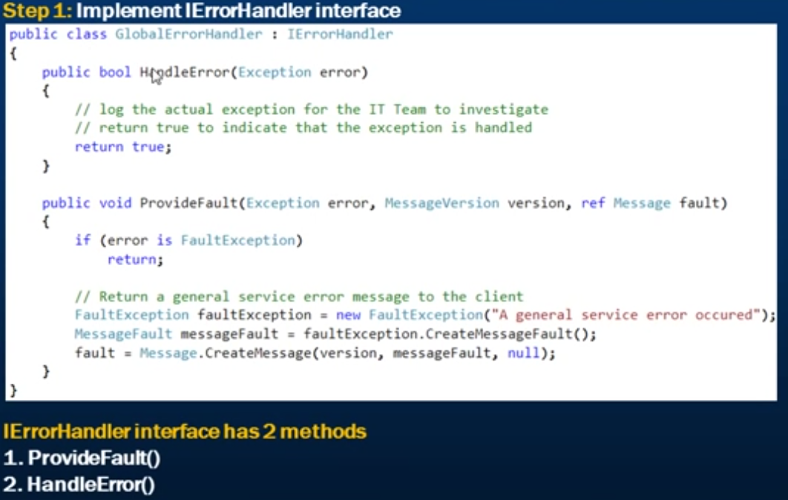

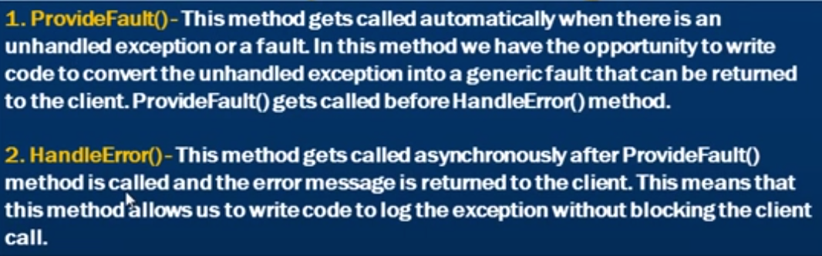

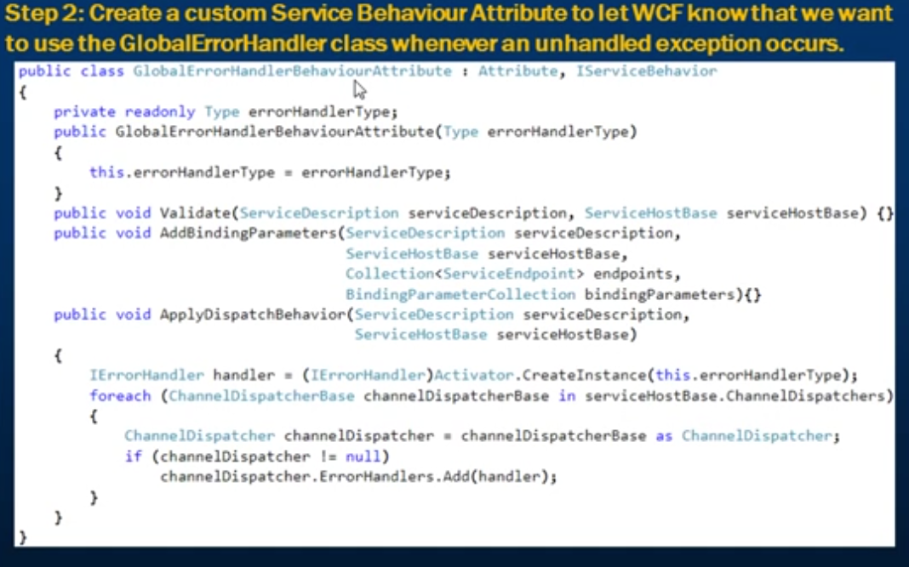

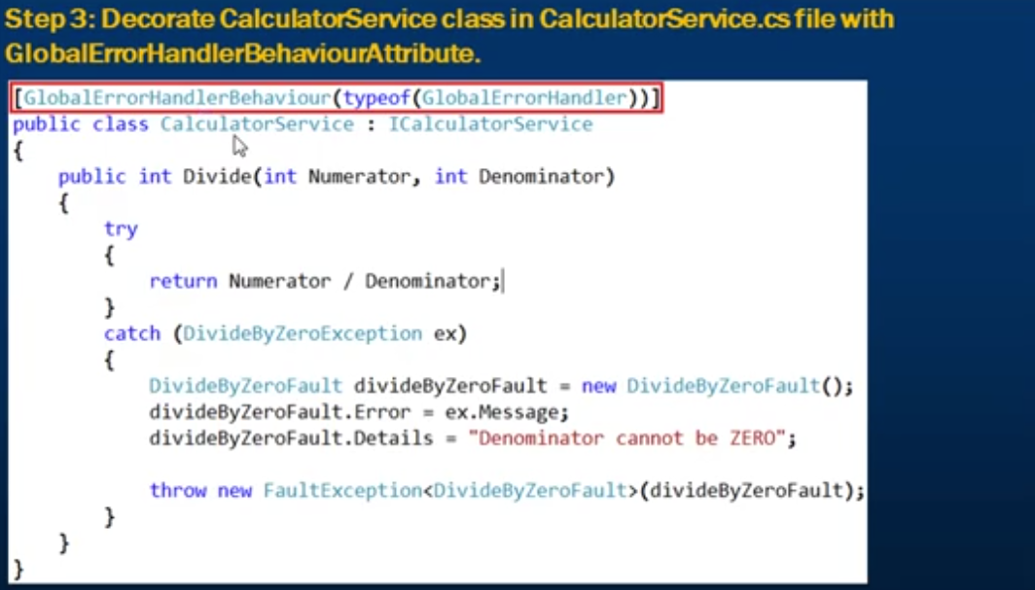

# Bindings in WCF

An endpoint is where the service is available for the clients to consume.

A WCF Service endpoint consists of 3 things

1. Address – address where the WCF Service is available
2. Bindings – it tells the message and the protocols for the endpoint.
3. Contract – specifies what the service can do. It describes which operations the client can perform on the service.

A WCF binding defines how the client needs to communicate with the service. The WCF binding that you choose determines the following for the communication between the client and the service.

1. Transport Protocol – HTTP, TCP, Named Pipe, MSMQ
2. Message Encoding – text/XML, binary
3. Protocols – reliable messaging, transaction support

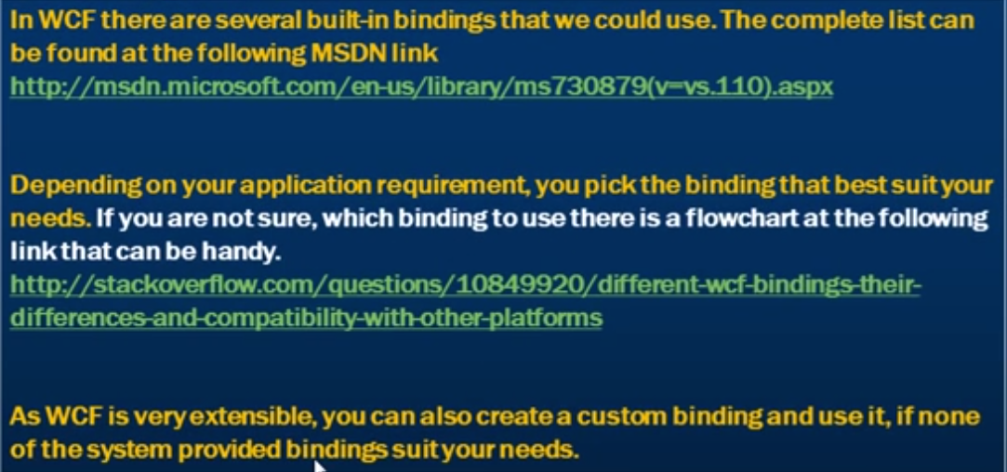

# Configure WCF service endpoint dynamically in code

We can configure an endpoint for WCF in2 ways

1. Declaratively using the configuration file
2. Dynamically in code

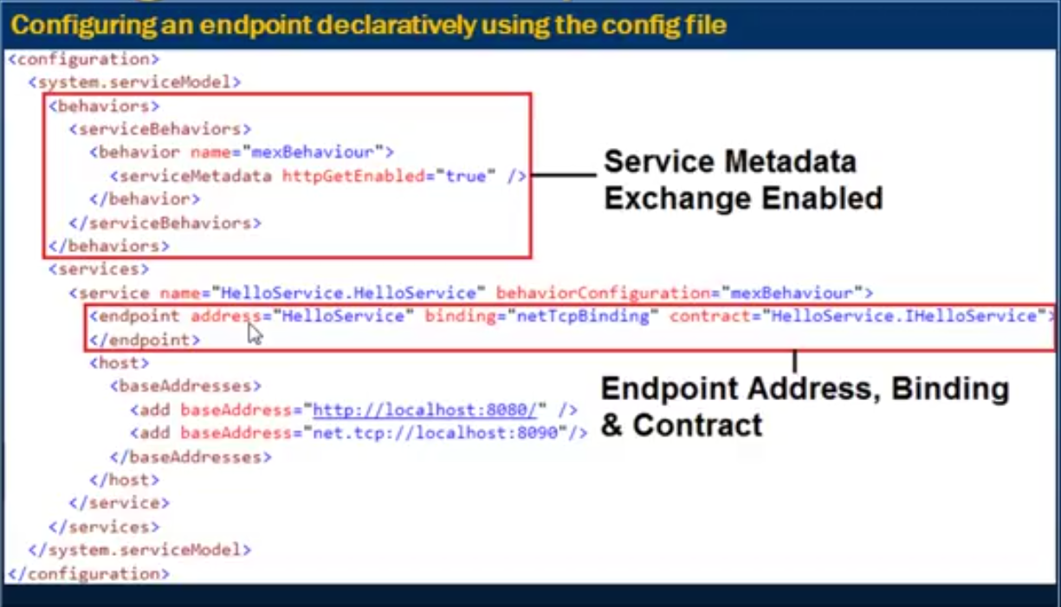

By enabling the service metadata exchange, we are letting the clients to generate the proxy classes automatically.

**Configuring service endpoint dynamically in code has the below steps:**

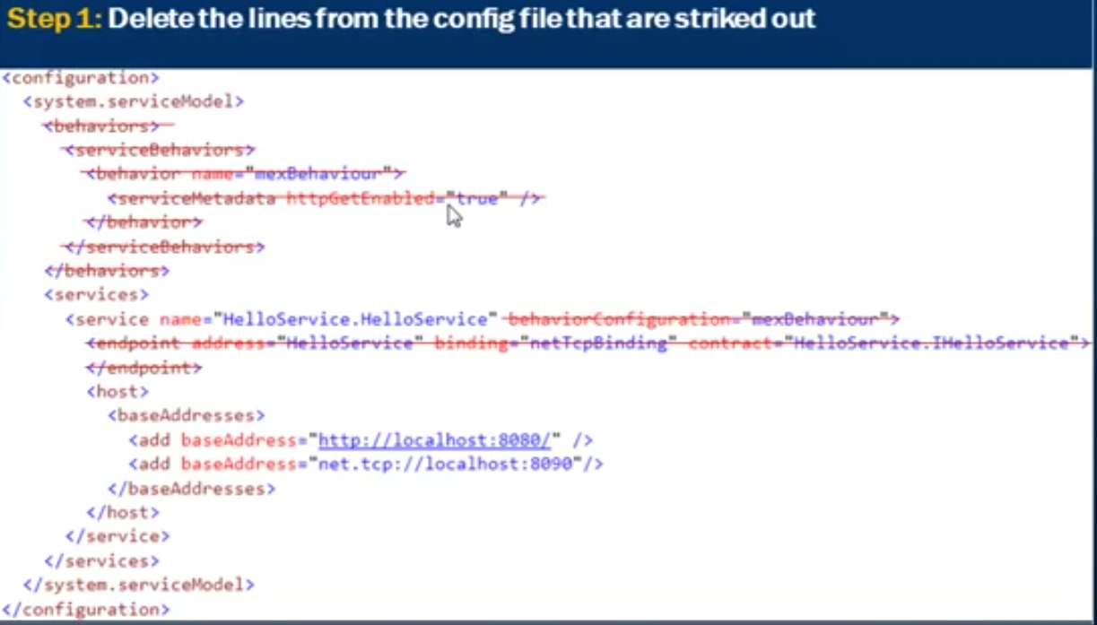

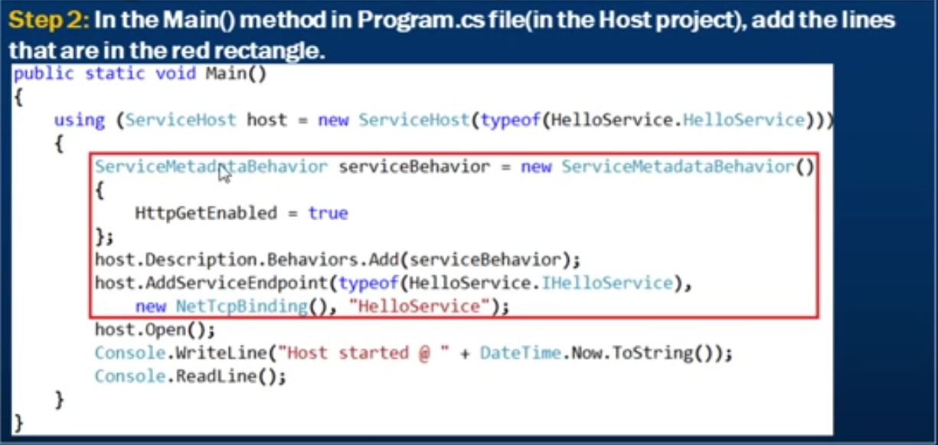

# Hosting WCF Service

For a WCF Service to be available for the clients to consume, we need to host the WCF Service. Below are the different ways in which we can do that.

|  |  |
| --- | --- |
| **Hosting Option** | **Description** |
| Windows Service | Hosting using a windows service |
| IIS (Internet Information Services) | Hosting within IIS supports only http bindings. Out of the box non-Http bindings are not supported. |
| Windows Activation Services (WAS) | Hosting a WCF Service using IIS 7 with WAS supports all bindings including the NON-HTTP bindings such as TCP, MSMQ etc |

## Self-hosting WCF Service using Console Application

Hosting a WCF Service in any managed .NET application is called self-hosting. Console applications, WPF applications, Win Forms Applications are all examples of managed .NET applications.

*Advantages of self-hosting a WCF service in a console application*

1. Very easy to setup. Specify the configuration in app.config file and with a few lines of code we have the service up and running.
2. Easy to debug as we don’t have to attach a separate process that hosts the WCF Service.
3. Supports all bindings and Transport Protocol.
4. Very flexible to control the lifetime of the services through the Open() and Close() method of the ServiceHost.

Create a class library project and to it add a WCF Service.

Create a console application to the same solution to host the WCF Service. Add a reference to System.ServiceModel to the console application references. Add an app.config file to the console application and provide the necessary configuration in this file. Necessary configuration includes service endpoints, behaviors for enabling metadata exchange. You can add the configuration by right-clicking the app.config file and selecting the Edit WCF Configuration or by through Tools -> WCF Service Configuration Editor.

Open the config file in the Editor and the click on the “Create a new Service.” Select the service type from the bin/debug directory of your Service project. Make sure to compile the WCF Service project once before doing this otherwise the Debug folder will be empty. Select the service type and click next

Select the contract and click next.

Select the binding and click next.

Provide the address. This address can be a fully qualified address or a relative/base address. Let’s type in the relative address as the name of the service itself and click next.

Finally click finish.

After this you can see the service added to the Service Configuration Editor under the Services Tab

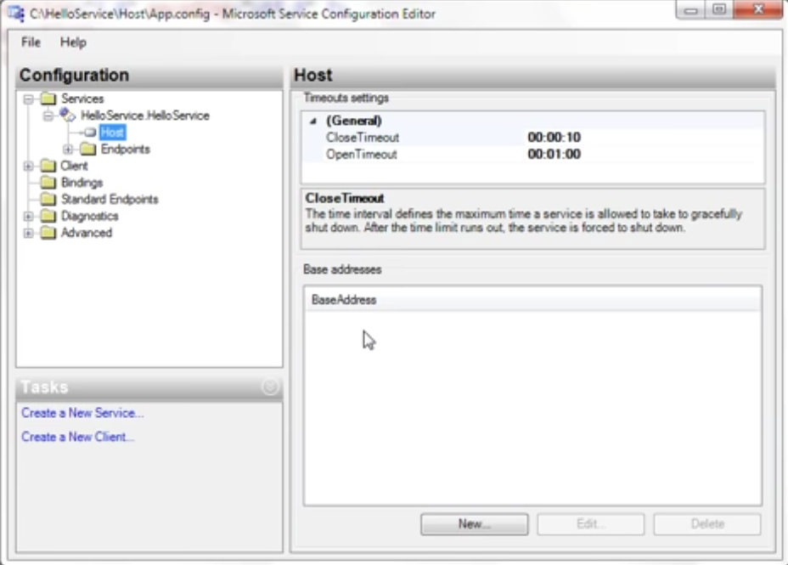

Select the Host tab to provide the base addresses.

Add the base address for both the metadata exchange and the service

<http://localhost:8080> - base address for metadata exchange

net.tcp://localhost:8090 – base address for the service with tcp binding.

**Note that the port may vary computer to computer.**

Create a New Service Behavior

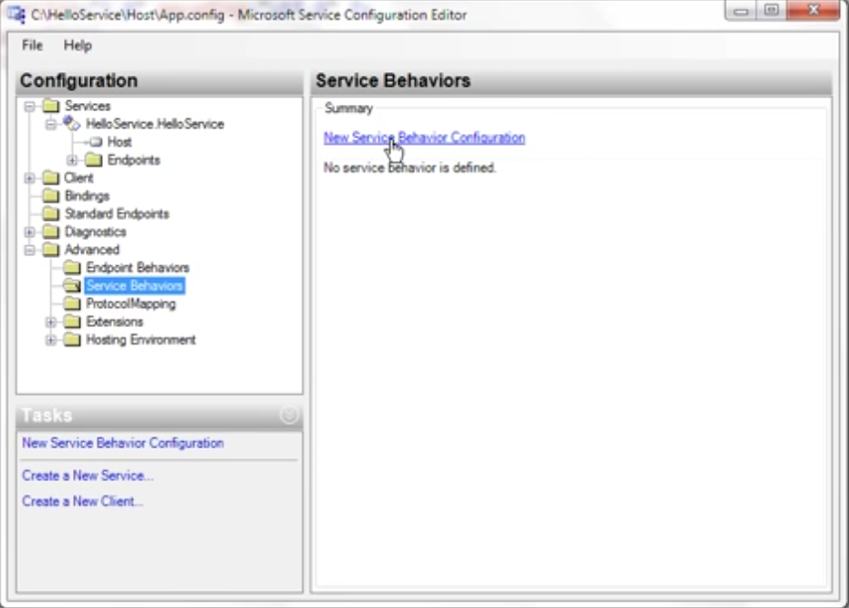

Add the service behavior for service metadata and then turn on the httpGetEnabled. Name the behavior as the “mexBehavior”

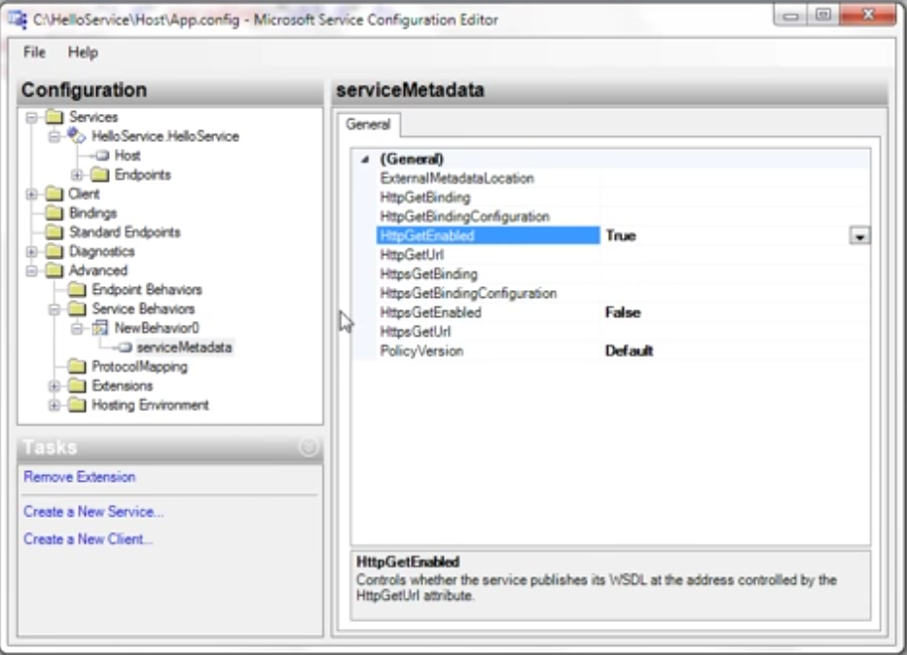

Finally associate the service behavior with the service itself.

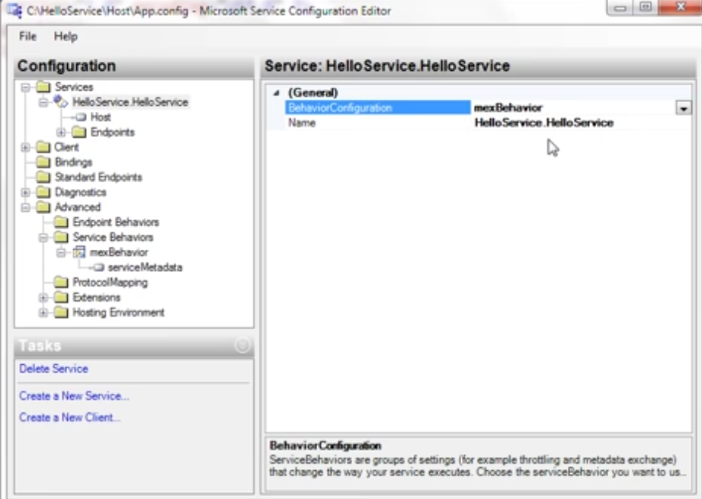

All of this can also directly be done in the app.config file as the whole process that we just go through generates the below code in the app.config file

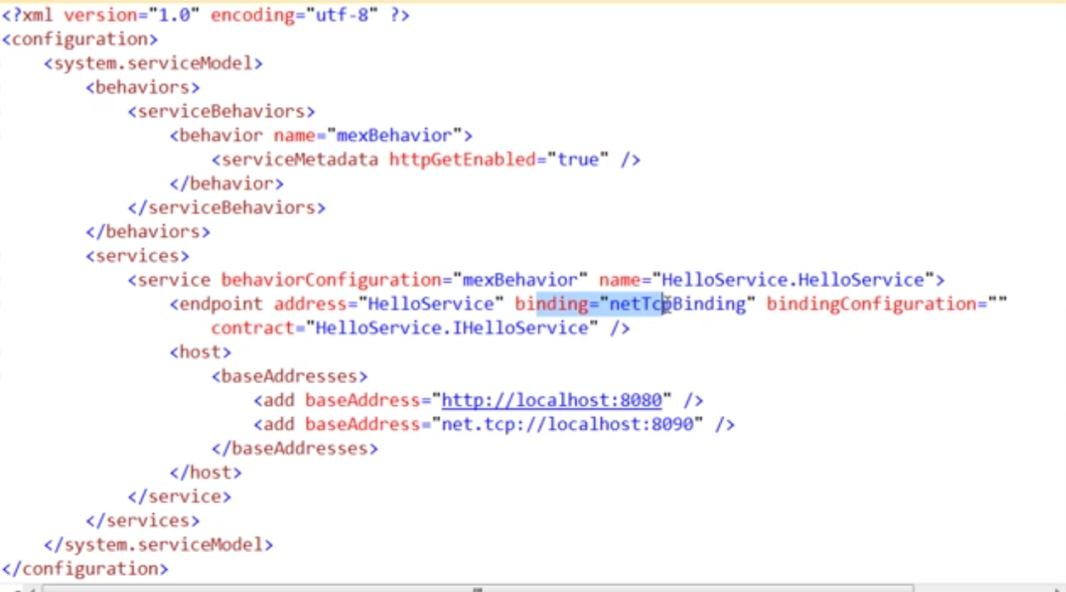

Finally host the service in the Program.cs file of the console application.

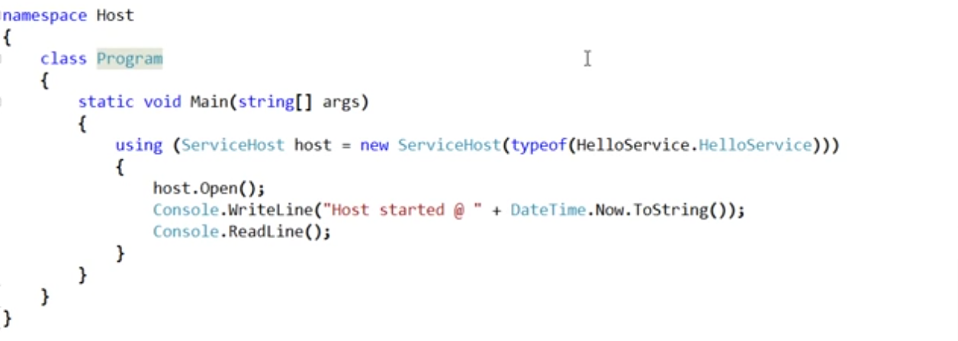

Set the console application as the startup project.

*Disadvantages of self-hosting a WCF Service in a console application is*

1. The service is available for the clients only when the service host is running.
2. Self-hosting does not support automatic message based activation that we get when hosted in IIS.
3. Custom Code required.

In general, self-hosting is only suitable during the development and demonstration phase and not for hosting live WCF Services.

## Self-Hosting a WCF Service using a Win Forms application

Create a Windows forms application and then add a reference to the WCF service. Also add a reference of System.ServiceModel to the references.

Add an app.config file same as before. Specify the service configurations like endpoints, service behaviors and base addresses etc just like we did it in the console.

And finally the code part.

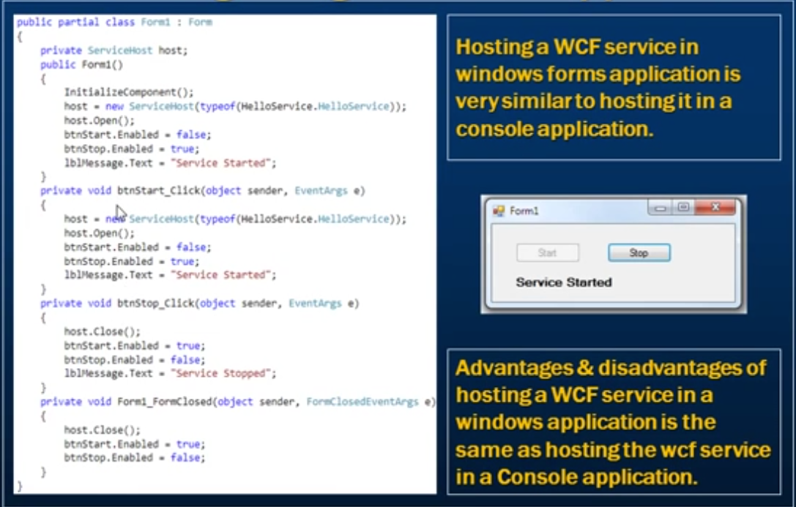

## What is a Windows Service?

A windows service is just like any other application running on a windows machine but it has the below differences.

1. It runs in the background
2. It can be configured to start automatically when the windows starts.
3. It does not have an interface.

Windows Services provide core operating system features such as

1. Event Logging – Windows Event log Service
2. Providing Security – Windows Firewall Service
3. Error Reporting – Windows Error Reporting Service.

***When would an asp .NET developer use a windows service?***

A developer can use a windows service to host a WCF Service. We can then configure the service when the computer starts. This makes our WCF service always available for the clients to consume, even if no one is logged on, on that computer.

## Hosting a WCF Service in a Windows Service

Create a Windows Service project and then add the reference of the System.ServiceModel and the WCF Service to the References of the project.

Add an app.config file and the service configurations like endpoints, behaviors, base addresses etc to it.

Finally, into the Service1.cs (renamed to HelloWindowsService) class file code the below to start and stop the host.

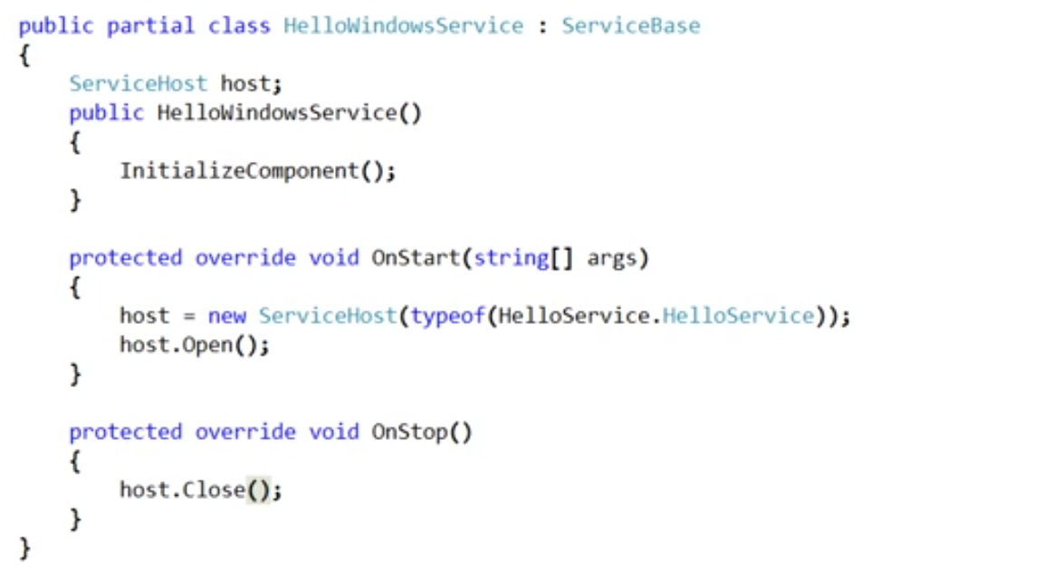

Open the HelloWindowsService.cs file and then on the design page right-click and select the Add Installer option. This will create and add a ProjectInstaller.cs file to the project.

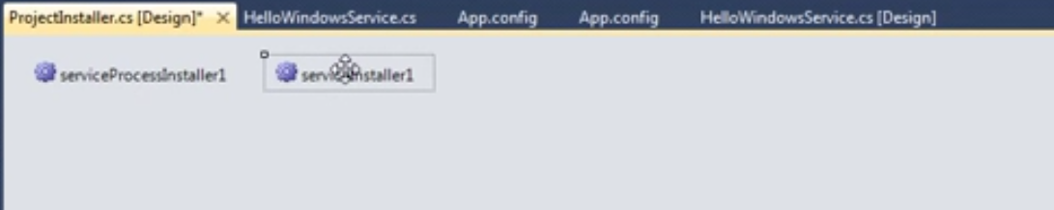

Select serviceInstaller1 and right-click and select properties. Specify the name of the Service. This is the name with which the service will be running. Change the start type from manual to automatic.

Select ServiceProcessInstaller1 and right-click and select properties. Specify the Account. This is the account with which the Service will be installed and run. Select Local System as the Account so that it can run with any Account.

Build the Solution.



To uninstall a windows service use the -u

## Advantages and Disadvantages of hosting a WCF Service in a Windows Service

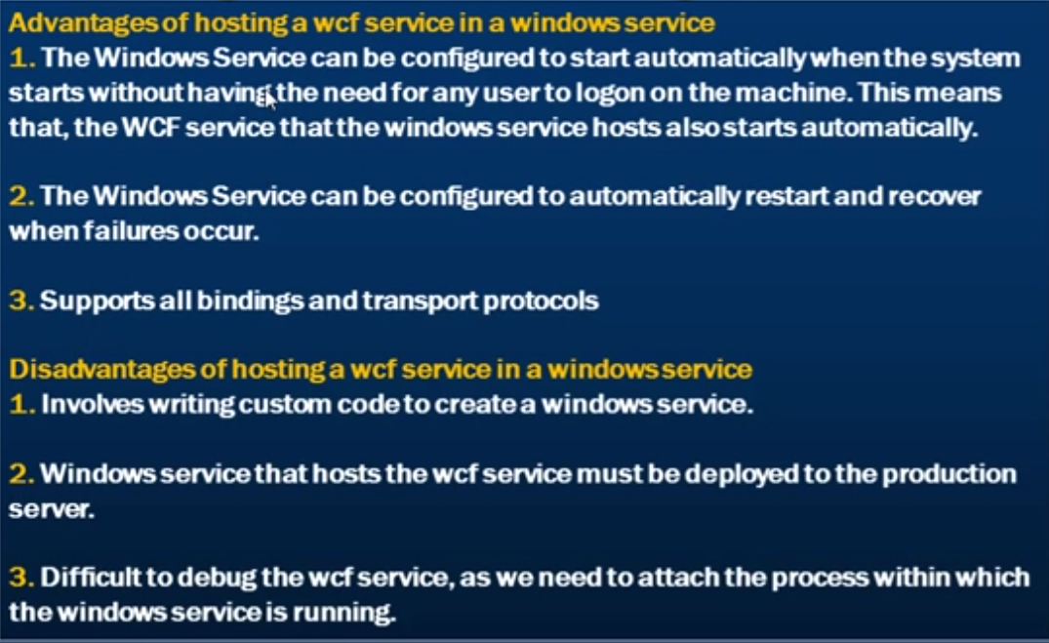

Go to Debug-> Select Attach to Process -> select the process with the same name as that of your client applicaton and click ok.

By doing this you will be able to debug the WCF service code.

## Hosting a WCF Service in IIS

To host the WCF Service to IIS, we need to add a Web application.

Right-click the solution project of the WCF Service and then add a “WCF Service” in the same project folder as that of the WCF Service present.

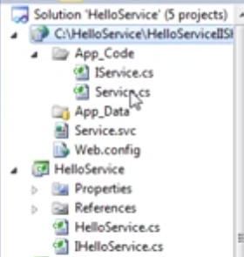

Notice that under the App_Code folder we have two classes IService.cs and Service.cs files. These files are there to specify our service code. Since we already have our WCF Service implemented as a separate project, we can actually delete these files.

Since we want to host the WCF Service, we need to add reference to the project. One you add a reference to the Hello Service WCF project, it will add the references in the Bin Folder.

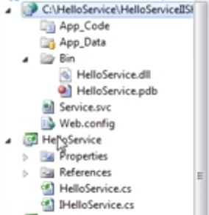

Now the **Service.svc** file is used by the IIS to locate the WCF Service. Let’s rename this file to ”HelloService.svc”.

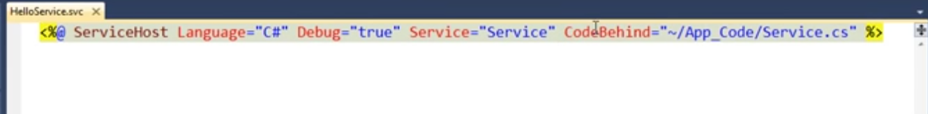

Now we can get rid of the CodeBehind attribute here since we no longer have our service code in the App_Code folder.

Change the name of the Service attribute to that of the fully qualified nae of your WCF Service.

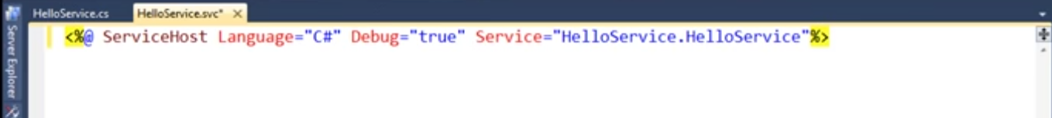

Now the web.config file needs to be updated to contain the code for the WCF service. We need to add the service endpoints, behaviors and base addresses as before.

Since IIS only supports http bindings we can remove the tcp.net base address.

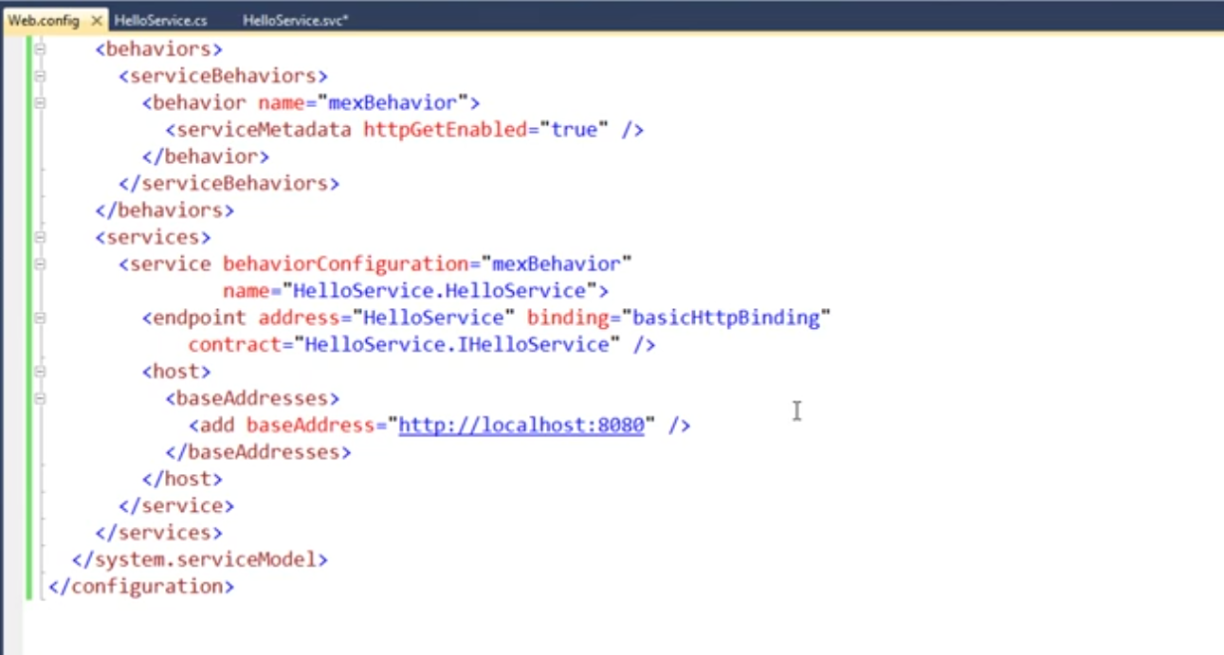

Next we need to create a virtual directory in IIS for this Web Site.

Open IIS -> Right-Click Default Web Site and select Add Application. Provide the below details.

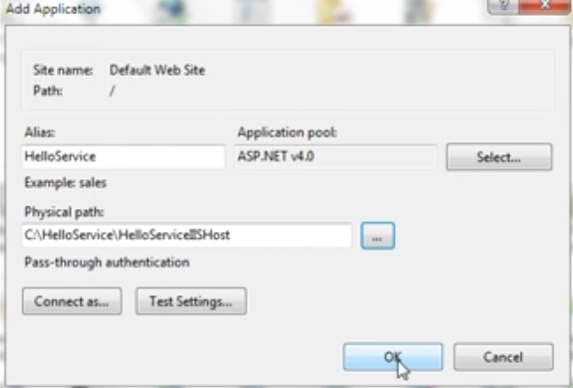

Now browse the HelloService.svc file. It will open the <http://localhost/HelloService/HelloService.svc> which contains the WSDL document.

Now in the client application add a Service Reference and provide the address for the WSDL document.

<http://localhost/HelloService/HelloService.svc?wsdl>

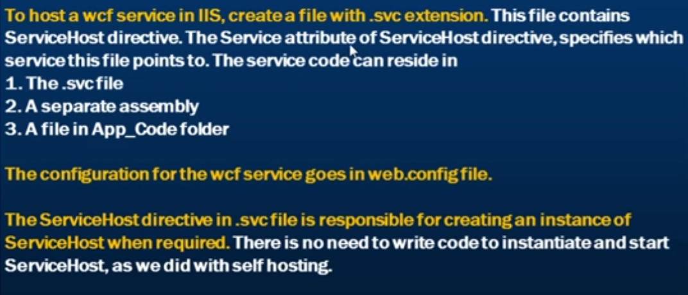

## Advantages and Disadvantages of hosting a WCF Service in IIS

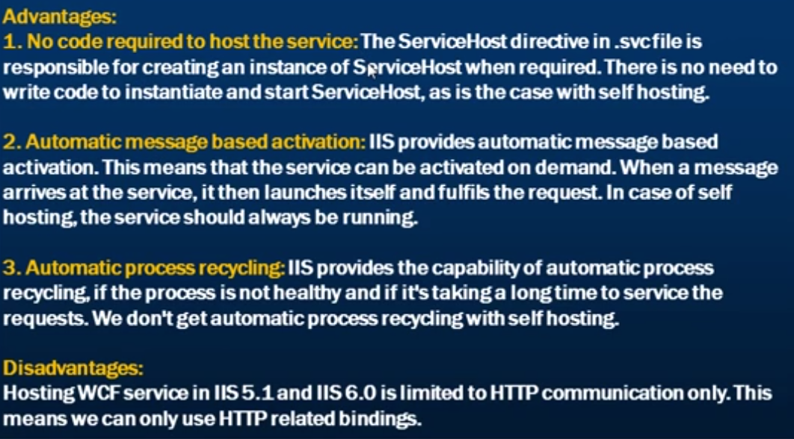

## WAS hosting in WCF

Hosting WCF Service in IIS 7 and enabling Windows Activation Service to support non-Http protocols like TCP.

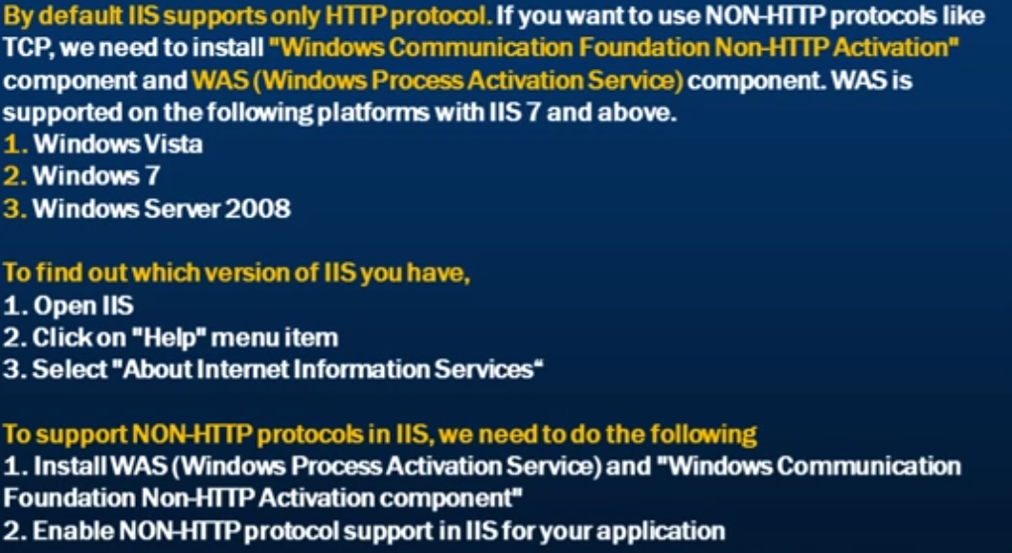

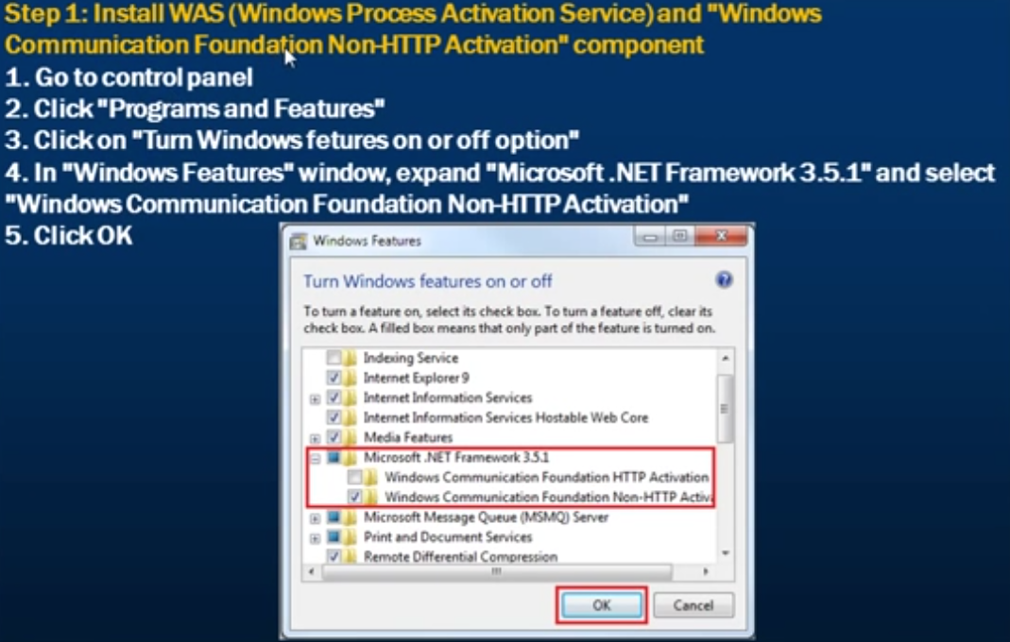

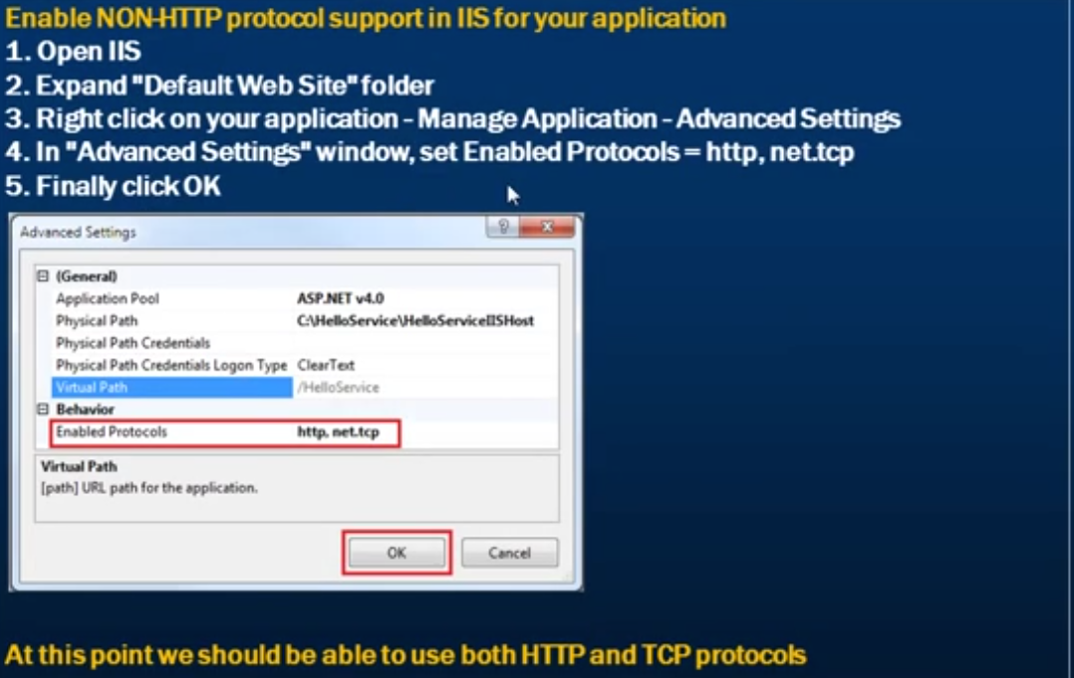

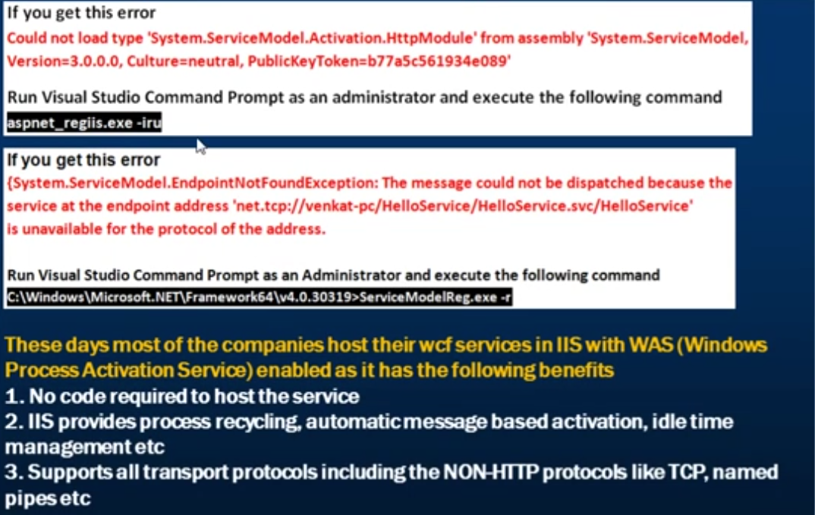

# Message Exchange Patterns in WCF

It describes how the client and the WCF Service exchange messages.

1. **Request-Reply (Default):**

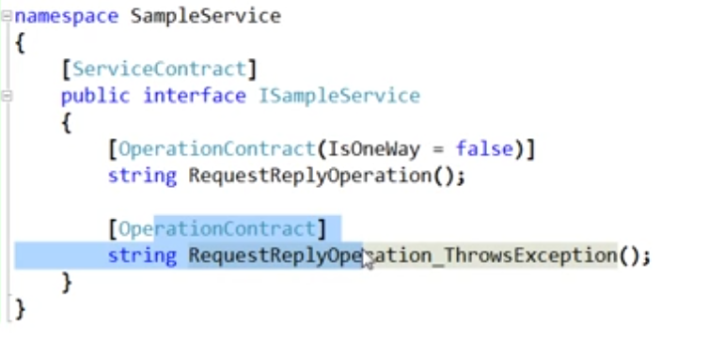

The message contract for the second operation contract is request-reply. This is because, unlike the first method, we haven’t used any parameter in the operation contract for the message.

The message exchange pattern for the first method is also request-reply because of the false in the IsOneWay. *We use the parameter in the operation contract to specify the message exchange pattern. The default value for IsOneWay is also false.*

As the name suggests, the client makes a call to the service and then waits for the service to send a response. During the wait period the process is blocked.

Even if the return type of the wcf service method is void, the client is going to wait for the service to return an empty message. Until then the client is waiting as the process will be suspended until the service method is finished its task.

When there is an exception in the wcf service method called by the client application, the exception is immediately returned to the client in the same call. This is what happens in the request-response message exchange pattern. *this does not happen in the One-Way message Exchange pattern.*

Any SOAP Call error will also be returned immediately.

If there is an unhandled exception in the service, it will fault the channel between the client and the WCF service. When the communication channel is faulted, we cannot use the same instance of the proxy class to communicate.

All WCF bindings except the MSMQ based bindings supports the Request-Reply Message Exchange Pattern.

1. **One-way**

In this type, only one message is exchanged between the client and the service. The client makes the call to the service method but does not wait for a response message. So, in short, the receiver of the message does not send a reply message, nor does the sender of the message expects one.

To make the message exchange pattern One-Way, just set IsOneWay to true.

As messages are exchanged only in one way, faults do not gets reported.

The client is going to send the message to the WCF Service and then the client will simply continue processing. When the call is received by the service, if the service is busy processing other requests, the call will get queued at the WCF Service waiting for it to be processed. In the mean time, the client is not blocked and can continue with other work.

Since it is a one way operation, we cannot return anything. We cannot even pass the reference variables or output variables. The return type of all one-way message exchange methods should be void.

If in a call to the service, an exception occurs in the service, then the client is not aware of the exception. When the client makes another call that’s when the communication channel gets into faulted state.

If you try to provide a return type other than void to any operation contract method in the service that exchanges messages in one-way, at the time of hosting, the service will throw an error and will not be able to host.

*Are one-way calls same as asynchronous calls?* No they are not. When an one-way call is received at the service, and if the service is busy serving other requests, then the call gets queue and the client gets unblocked and can continue executing while the service processes the operation in the background. **One-way calls can still block the client,** if the number of messages waiting to be processed has crossed the server queue limit. So, one-way calls are not asynchronous. They just appear to be asynchronous.

1. **Duplex**

It can be implemented using request-reply or one-way operations.

Suppose we need our service to process a report which is a lengthy process. Now we don’t want to use the Request-Reply as the client will be blocked till the service completes the operation.

We also don’t want the one-way pattern as the client will have no way to get the status of the operation whether it is in process or completed or how much the process is complete.

If we want to receive the status, the we need some sort of listener or a callback method at the client that the WCF Service can call and pump messages into. And this callback method in the client will take the responsibility of displaying the message or whatever it needs to do with the message.

So, we need to have a callback contract in the WCF Service, which the service can call and send messages to.

**Callback Contracts need not to be decorated with the SErviceContract attribute.**

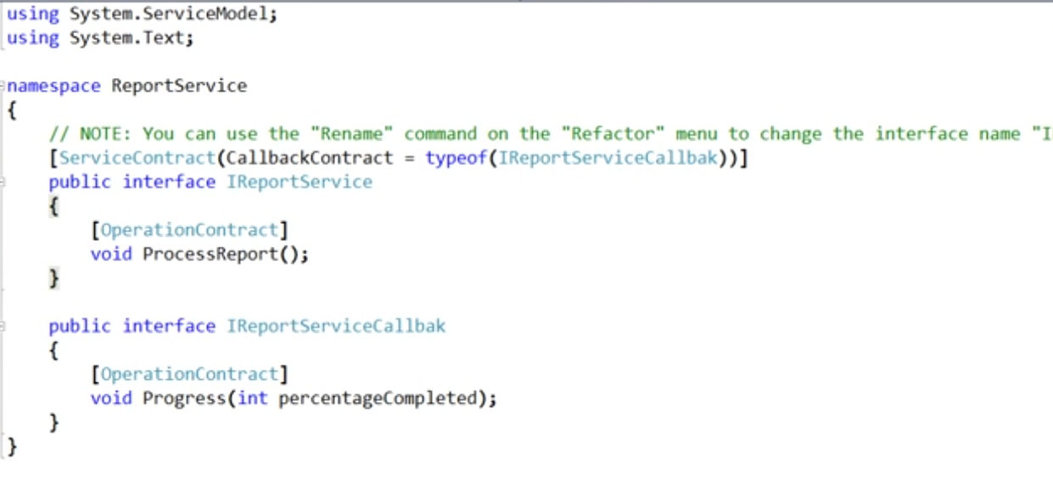

Specify a Callback Contract and associate it with the Service Contract.

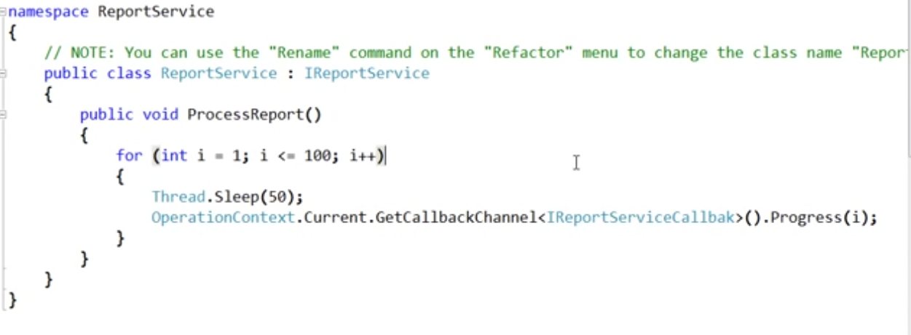

Now we are done from the WCF service point of view.

On the client side, we need to implement the method of the callback interface of the WCF Service.

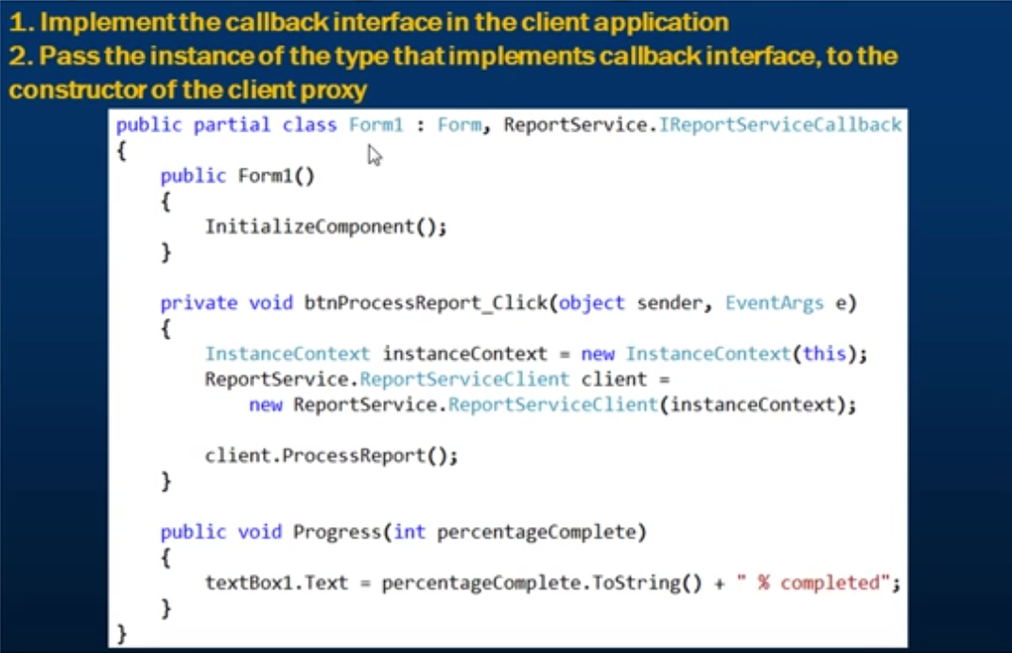

The instance context here is the instance of the Form1 class as this is the class implementing the callback interface.

Here, we will end up in a situation of deadlock because the client is busy In waiting for the response from the service, the service wants to send a message to the callback method. Since the thread of the client is busy in waiting because of the message exchange pattern of Request-response type, we end up in deadlock.

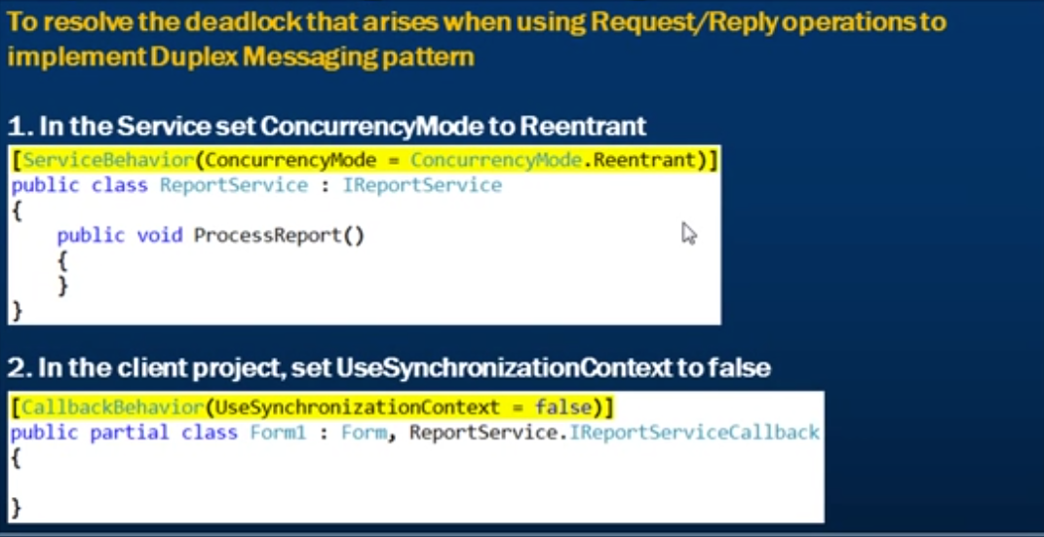

Now if we want to achieve the same with the One-Way pattern, we first need to get rid of the two decorators we used in the last statement to resolve the deadlock issue. Since we have only one way message, we would not end up in any kind of deadlock situation here.

Next make the operation contracts one-way by setting IsOneWay = true.

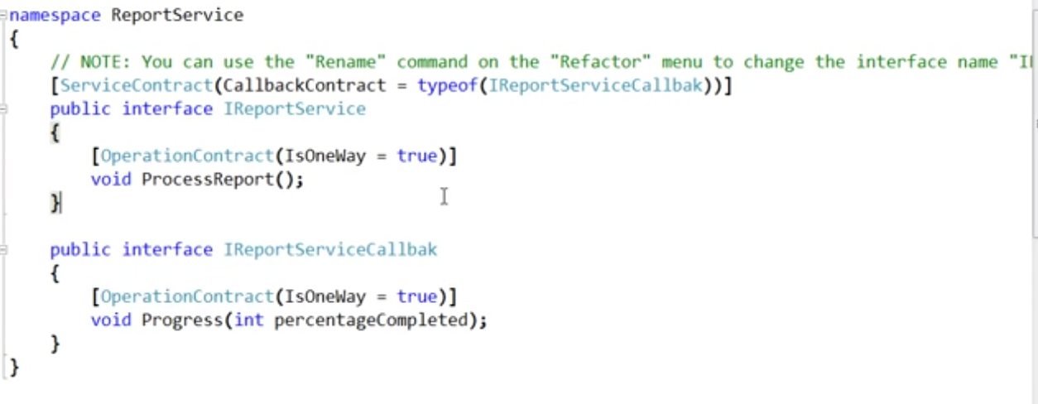

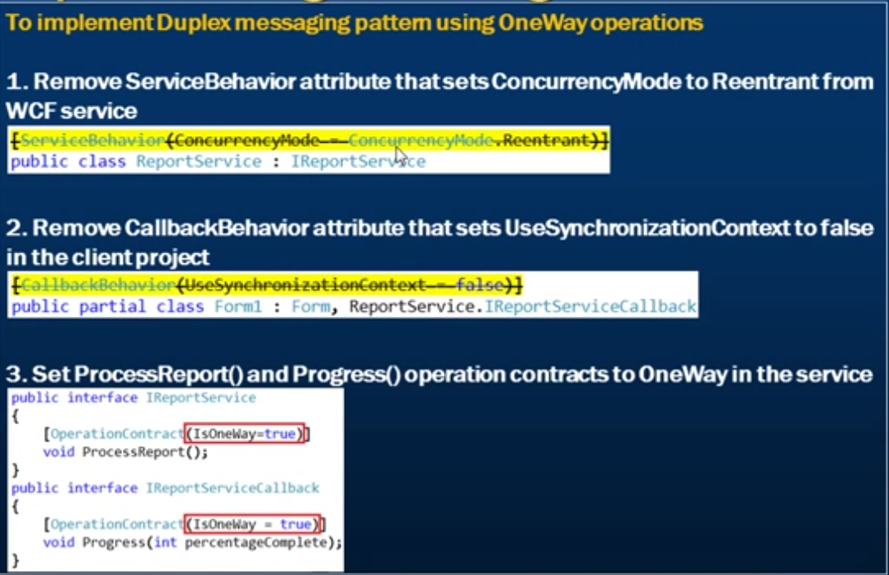

## Sending Large Messages in WCF using MTOM

The default message encoding mechanism in WCF is Text, which base64 encodes data. This has the following 2 disadvantages.

1. Base64 encoding bloats the message size by approximately 33%
2. Involves additional processing overhead to base64 encode and decode.

The preferred approach is to send large binary messages in WCF is to use MTOM messaging encoding. MTOM is an interoperable standard and stands for Message Transmission Optimization Mechanism. MTOM does not base64 encode data. This also means that the additional processing overhead is removed. Hence, it can increase the overall message transfer performance.

With Text Message encoding, the binary data is base64 encoded and it is embedded in the SOAP envelop. With MOTM, the binary data is included as a MIME (Multipurpose Internet Mail Extension) attachment.

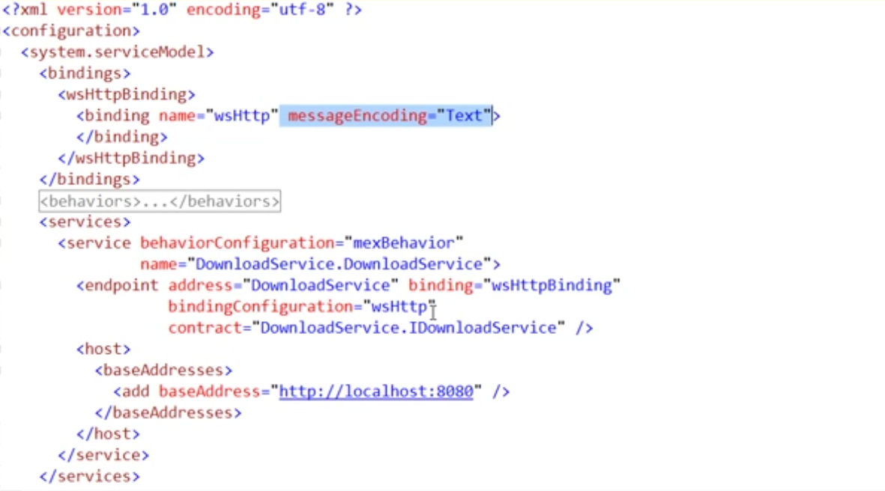

Change the bindings int the host config file in case of the max array size error in the service while downloading the file/read/write the file.

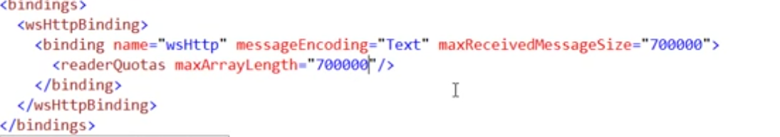

We need to do the same thing in the client side application config also.

Just provide the readerQuotas and maxReceivedMessageSize also.

Just change the message enoding to MTOM

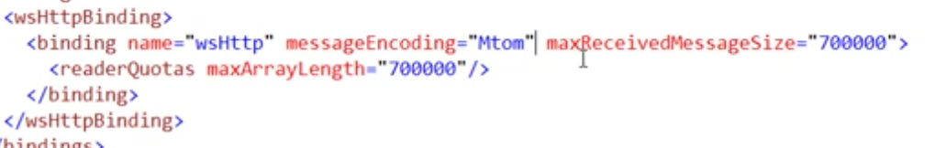

Also do the same thing with in the client application.

# Instancing Modes in WCF

It is also called instance context mode.

When a client makes a request to a WCF service, the service will make an instance of the service itself and on that service instance, we invoke the respective operation. Once the operation is complete, the service returns the response back to the client.

*Now, the question comes is that, what happens to the service instance? Does the service instance remains the memory for forever that is for the lifetime of the application or the instance is destroyed after the request is fulfilled or the instance remains on the server for the session of the client?*

Instance context mode dictates how long the service instance remains on the server

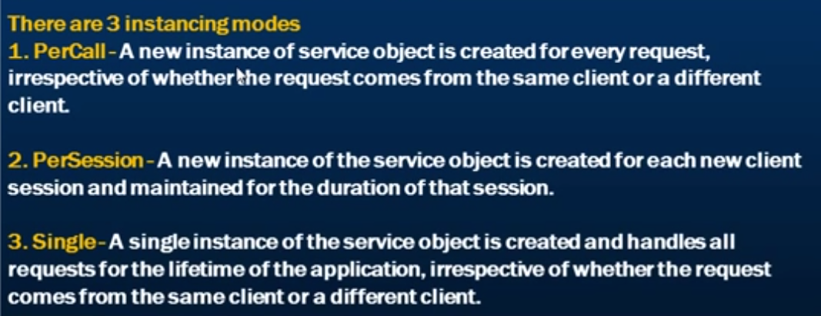

Since in the **PerCall mode**, it is a new instance for every request, the instance is destroyed as soon as the request is fulfilled. This also means that the **state between the requests is not maintained**.

In **PerSession**, the **state is maintained** for all the requests in a single session.

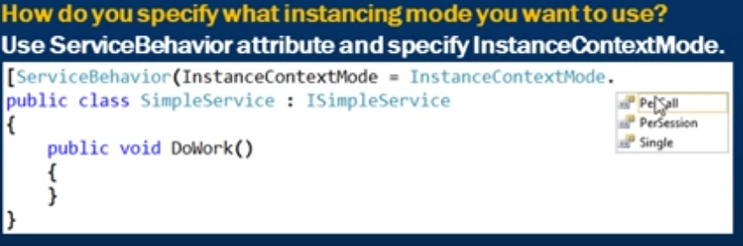

## PerCall Instance Context Mode

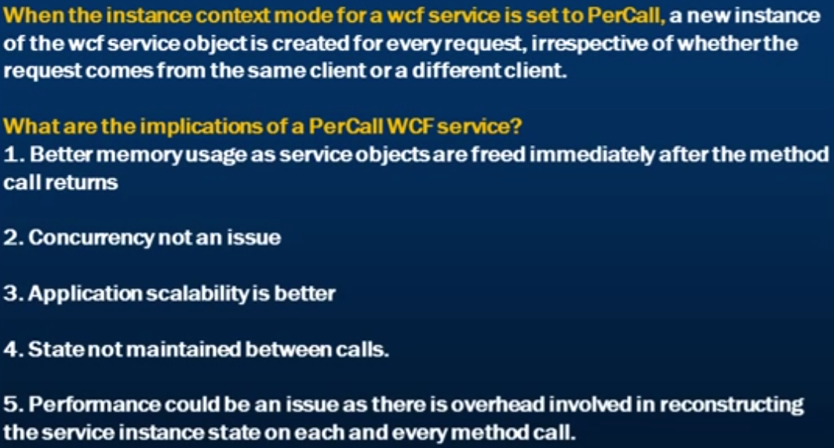

## PerSession Instance Context Mode

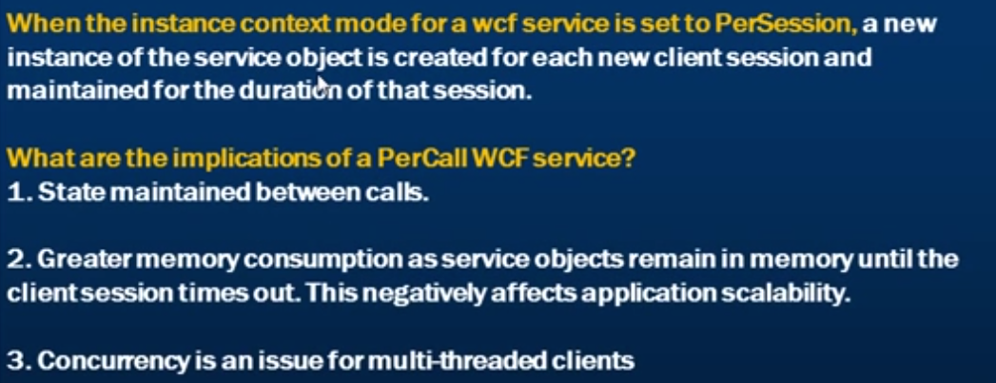

**The default session timeout is 10 minutes.**

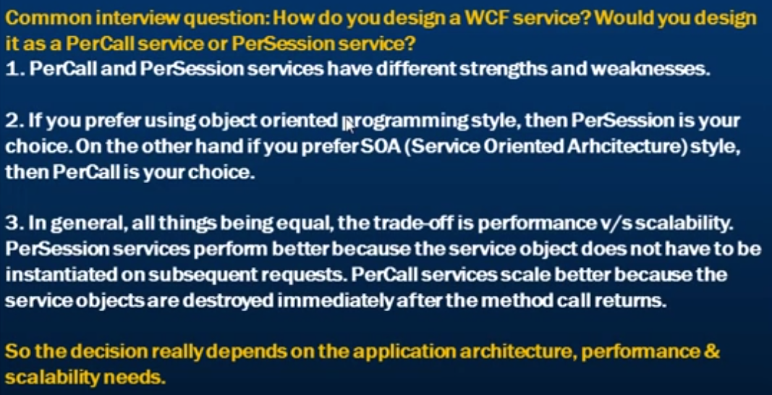

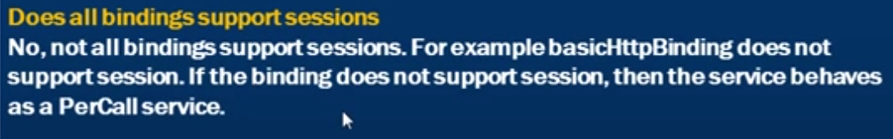

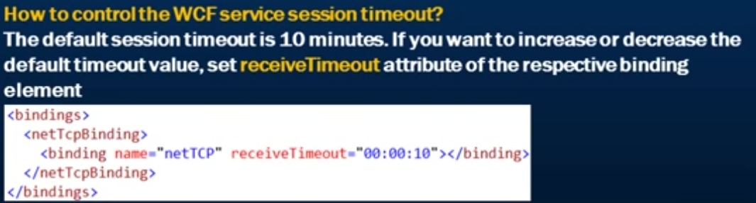

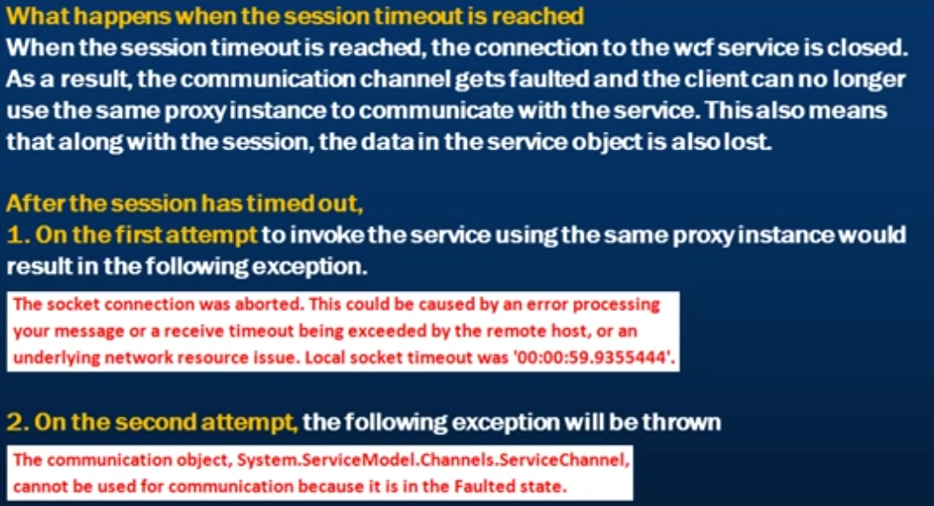

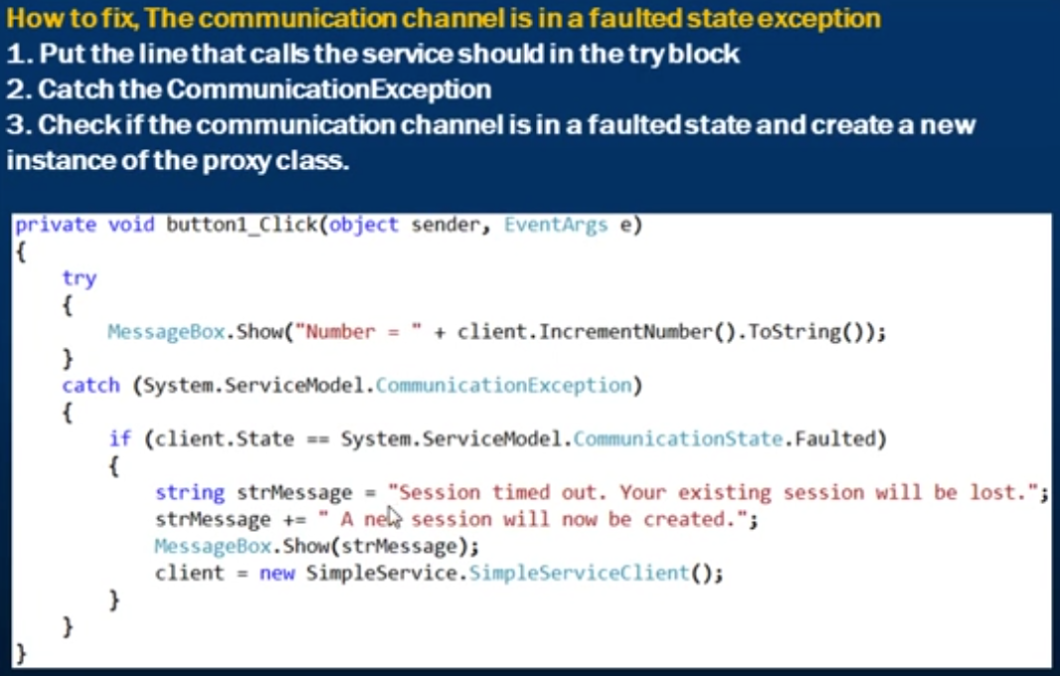

## Retrieving Session Id in WCF Service and in the Client Application

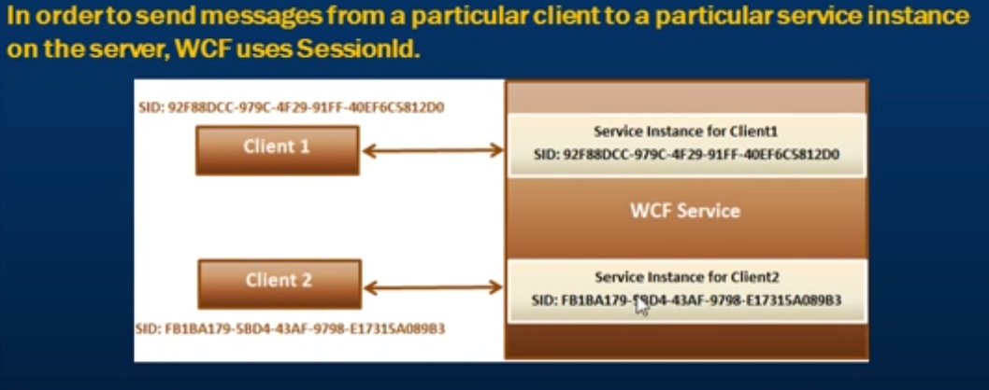

Notice that the client1 Session Id is same as the Service instance for client1 and so on.

There are different types of sessions in WCF.

Transport Session, Application Session, Reliable Session etc.

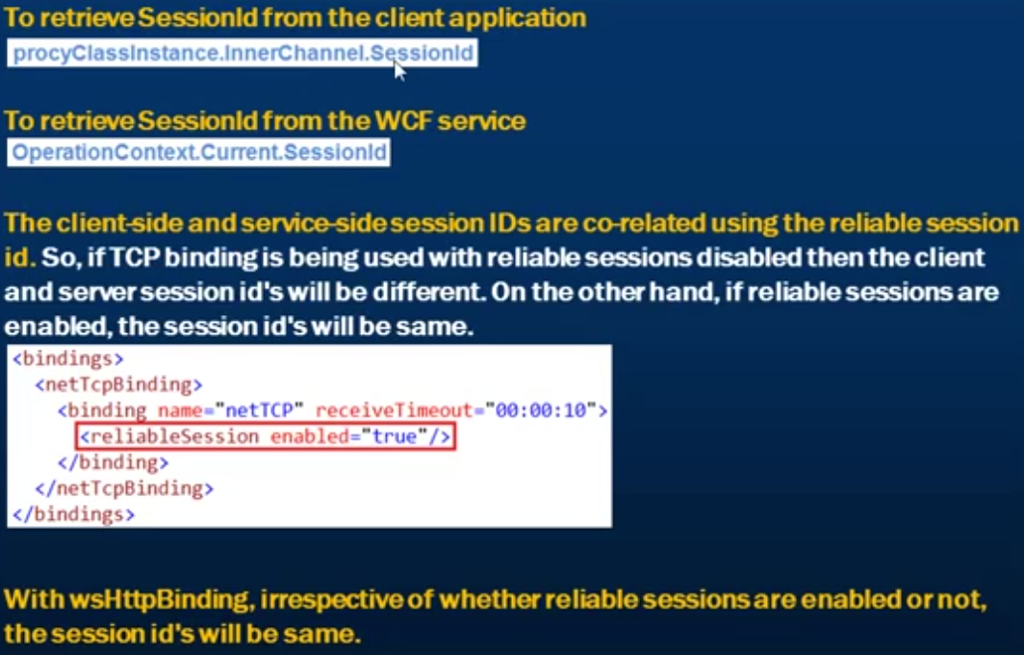

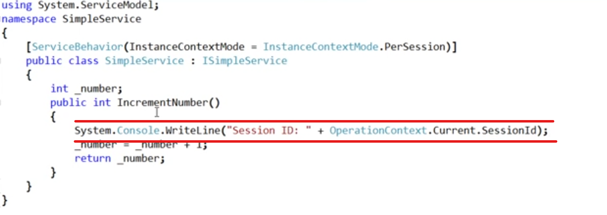

In the client side, to get the session id

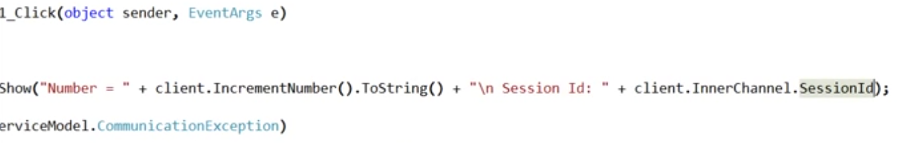

## Singleton WCF Service

A WCF Service is call singleton when there is only one service instance created of the WCF Service. This can be achieved by using the InstanceContextMode to Single.

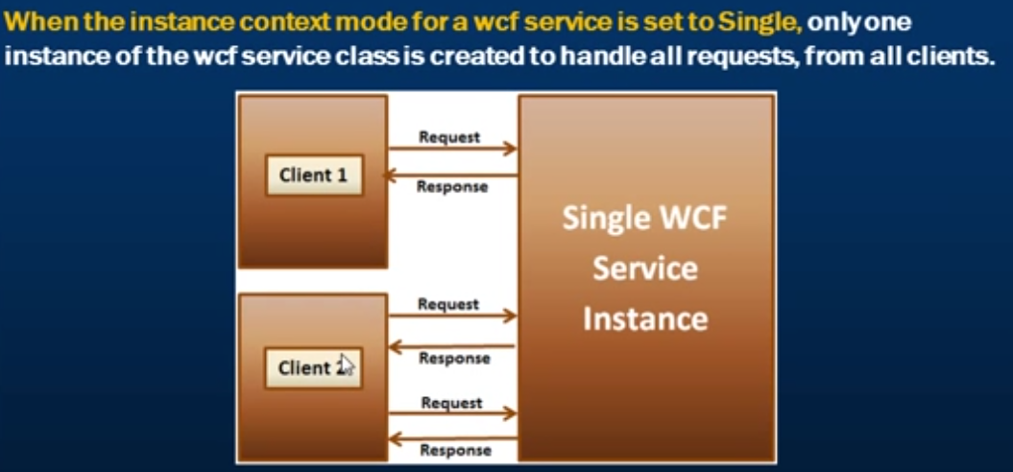

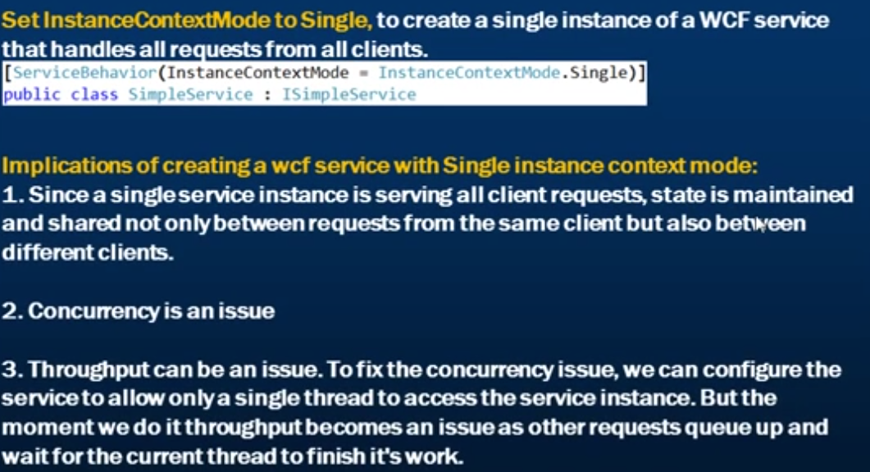

## Session Mode Enumeration

Use Session Mode enumeration with the Service Contract to require, allow or prohibit bindings to use sessions.

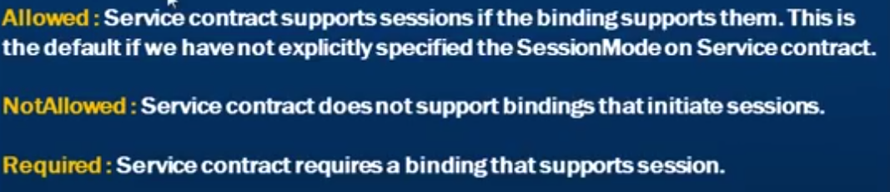

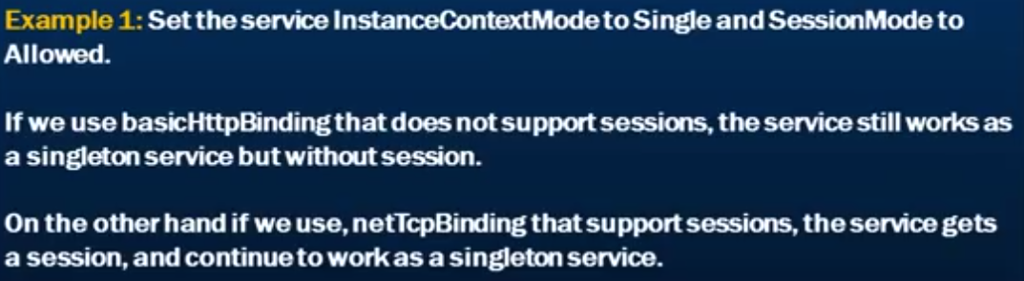

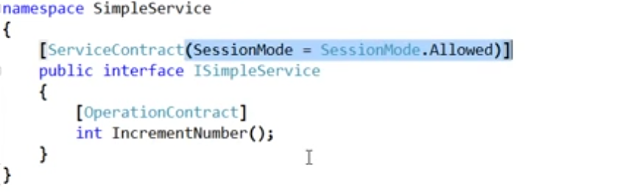

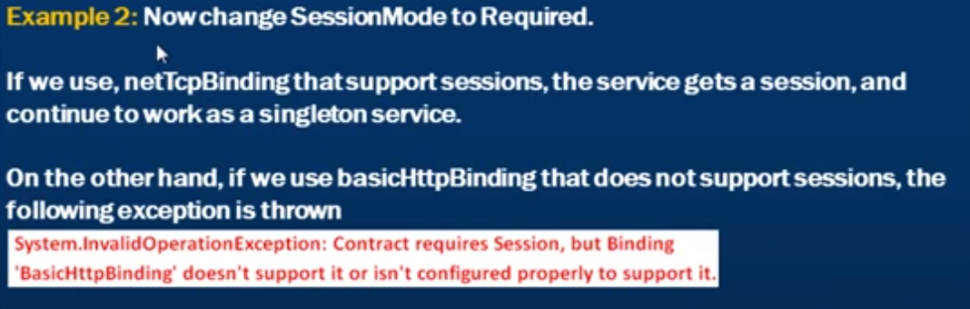

# WCF Concurrency

**Throughput** is the amount of work done in a specified amount of time.

Multiple threads executing the application code simultaneously is called as concurrency. In general, with concurrency we get better throughput. However, concurrency issue can occur when multiple threads access the same resource. In WCF, service instance is a shared resource.

## Single Concurrency Mode

**The default concurrency mode in WCF is single.** This means that only a single thread can access the service instance at a given point in time. While a request is being processed by the service instance, an exclusive lock is acquired and all other threads will have to wait until the current request completes and the lock is released. Upon releasing the lock, the next thread in the queue can access the service instance.

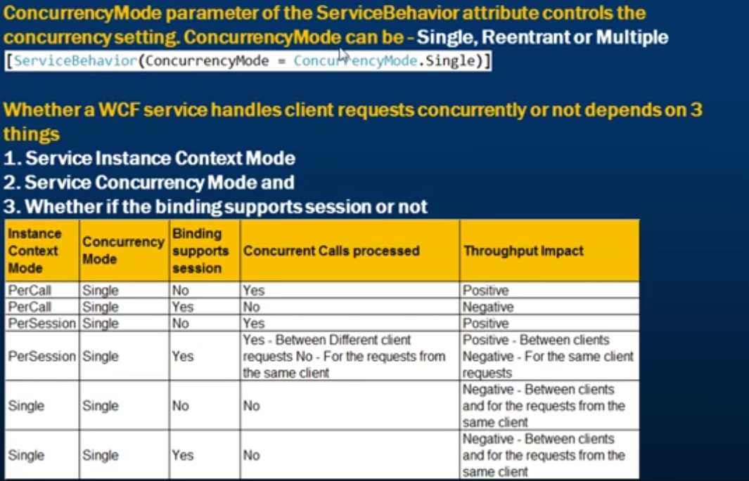

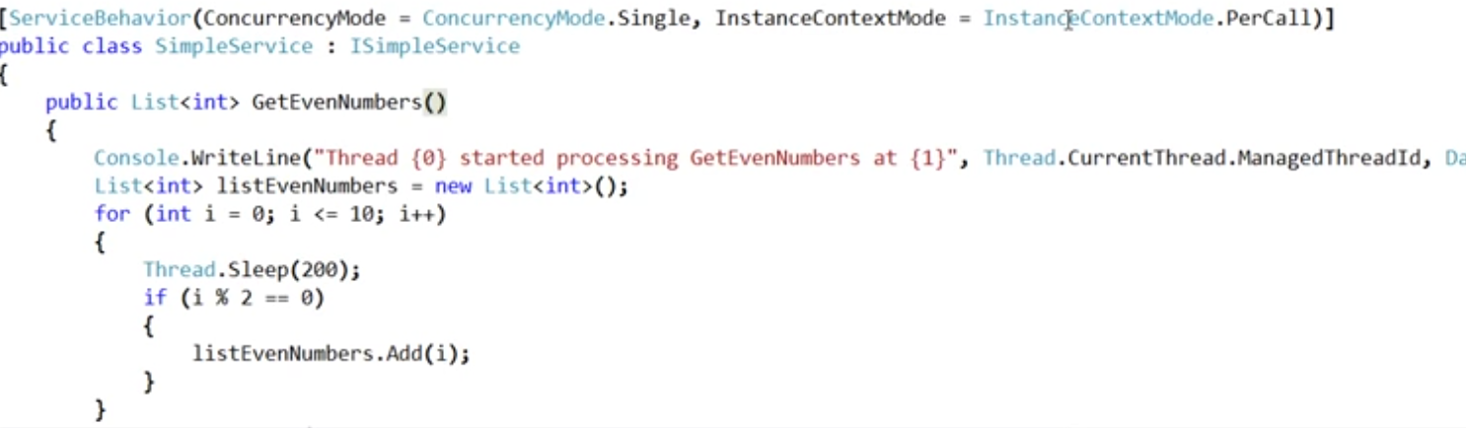

Thread.CurrentThread.ManagedThreadId gives us the id of the thread processing the request.

## Multiple Concurrency Mode

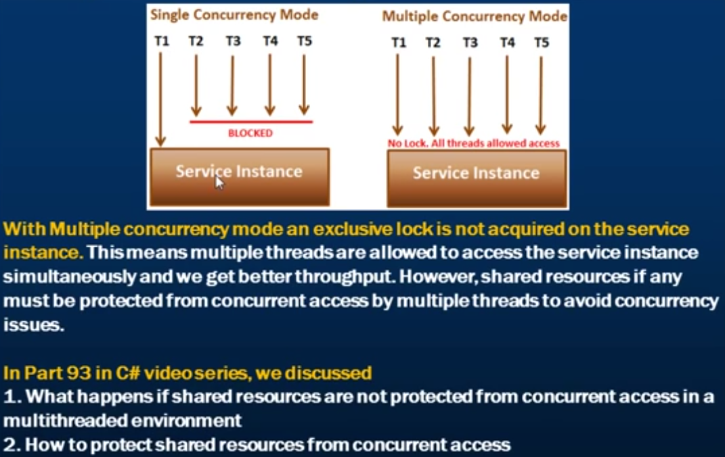

When we set the concurrency mode to multiple, the service instance context mode and whether the underlying binding supports session or not doesn’t really have any influence on the capability of the WCF service as a whole to process calls concurrently.

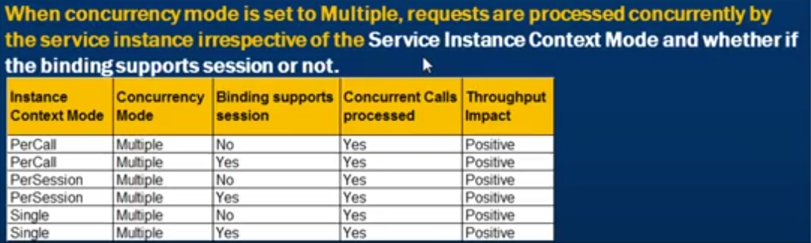

## Reentrant Concurrency Mode

This mode allows the WCF Service to issue callbacks to the client application.

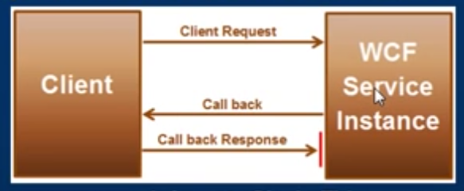

Let’s assume now that the concurrency mode is set to single. This means that only one thread is allowed to access the service instance.

**Now, let’s say that the client makes a request to the WCF Service. The service instance gets locked by the thread that is executing the client request. At this point, no other thread can access the service instance until the current thread is completed and the lock is released.**

While the service instance is processing the client request, the service wants to callback the client. The callback operation is not one way. This means that the response of the callback from the client needs to get back to the same service instance. Since the service instance is locked, the response from the client cannot reenter and access the service instance. This situation leads to a deadlock.

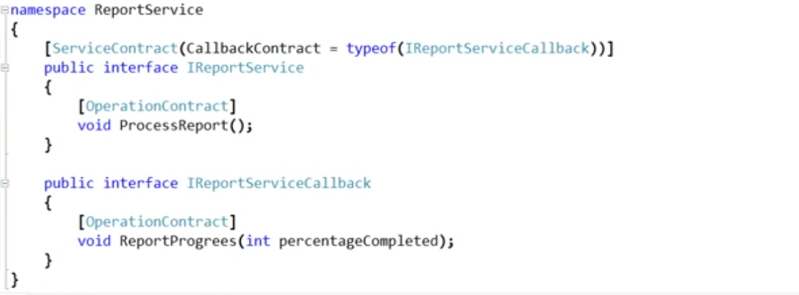

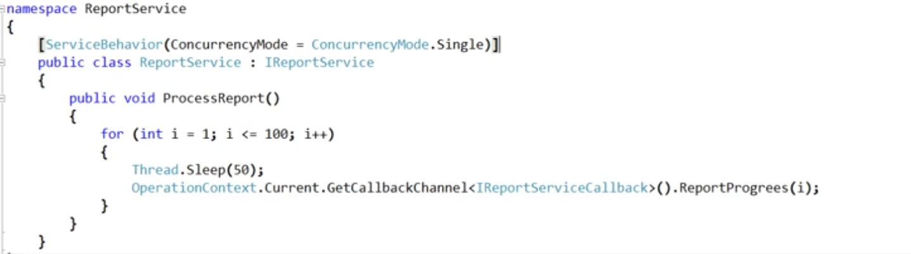

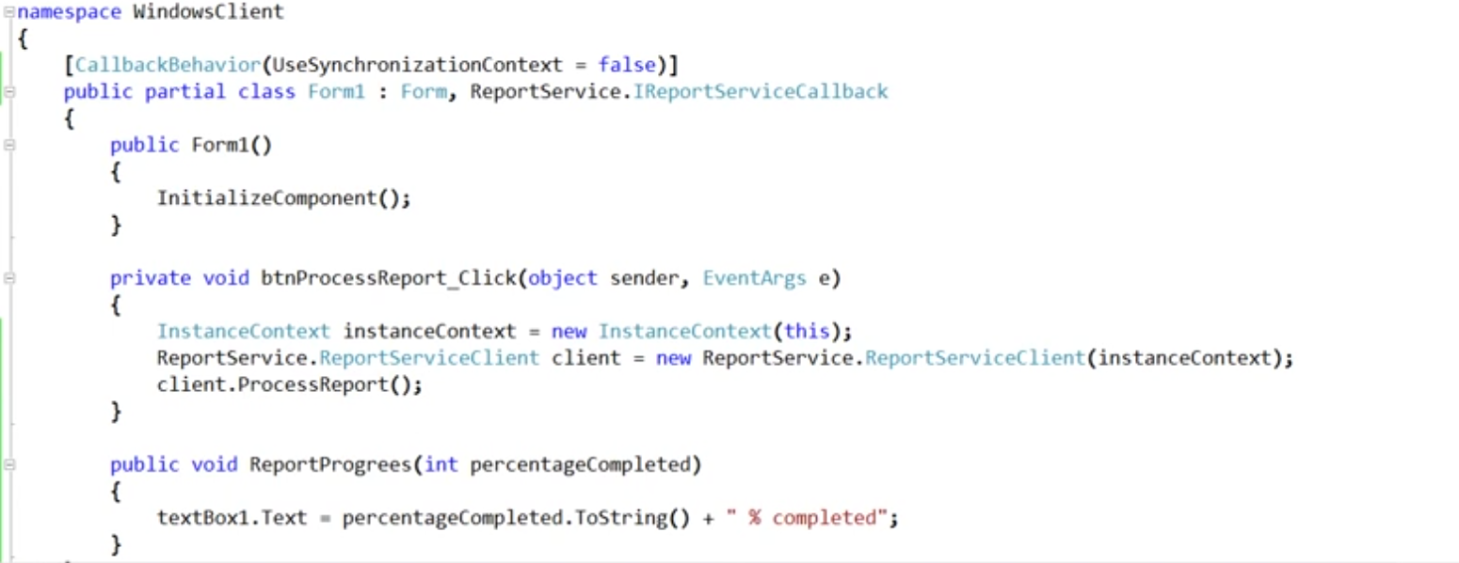

The deadlock can be resolved by setting the concurrency mode to **Multiple or Reentrant**.

By default, the message exchange pattern is set to request-response. **The another even better way to solve the deadlock is to** set the message exchange pattern to One-way for the callback method. This should be done only if there is no need to get the callback response from the client.

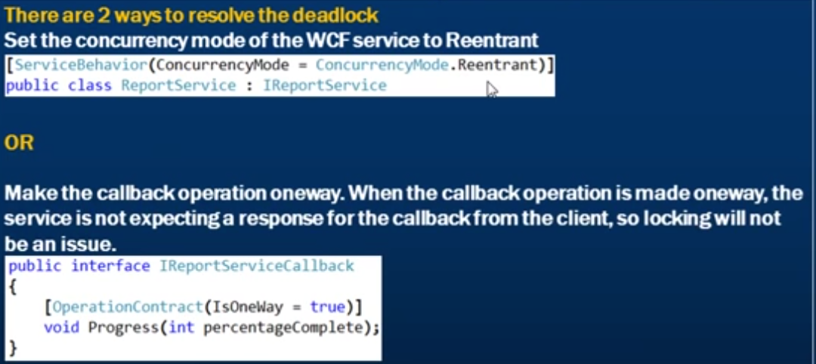

# WCF Throttling

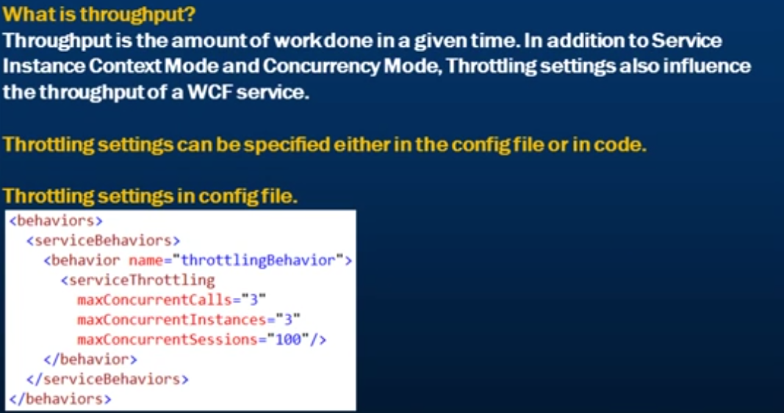

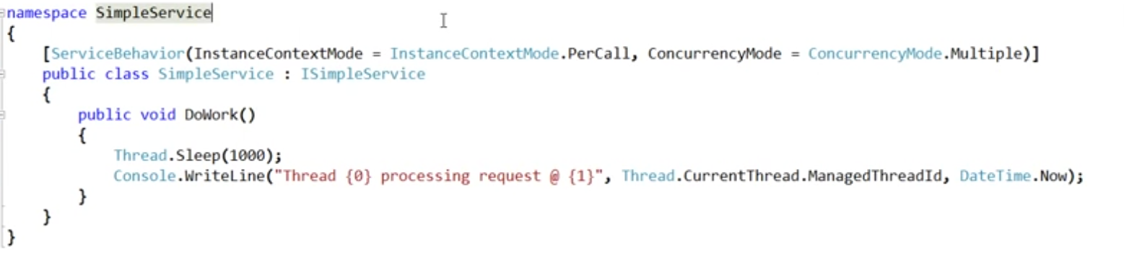

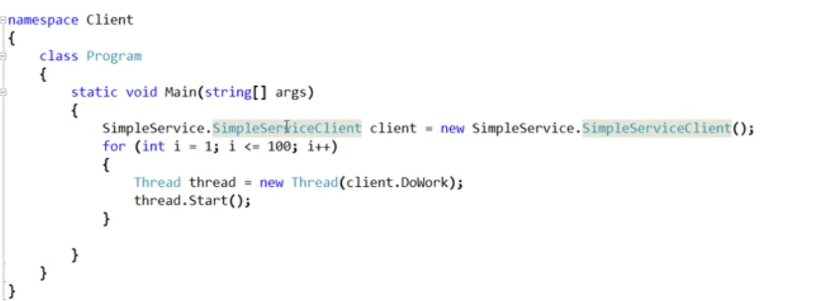

Let’s run both our client and the service.

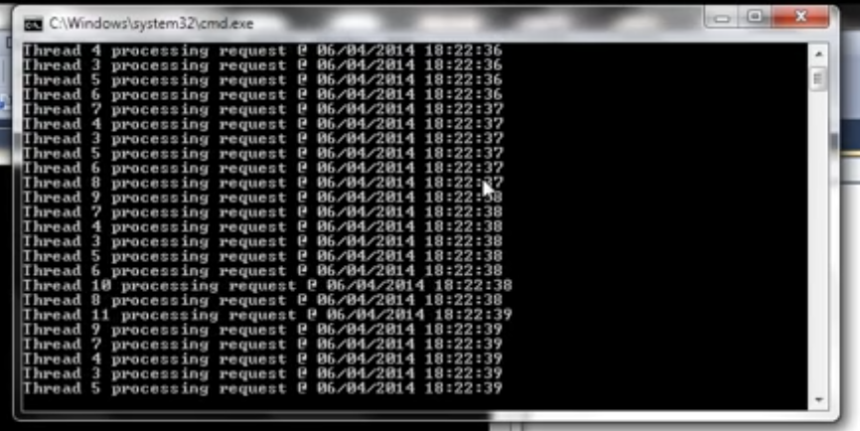

Notice that there are multiple threads that are being executed at a given point of time. The number of threads executing increases every second.

When we set the concurrency mode to Multiple, we don’t have control on how many threads can execute the concurrent calls. If we intend to control that, we can make use of the **throttling settings.**

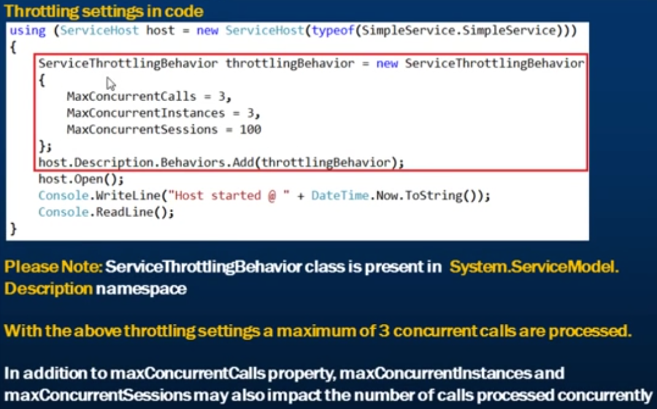

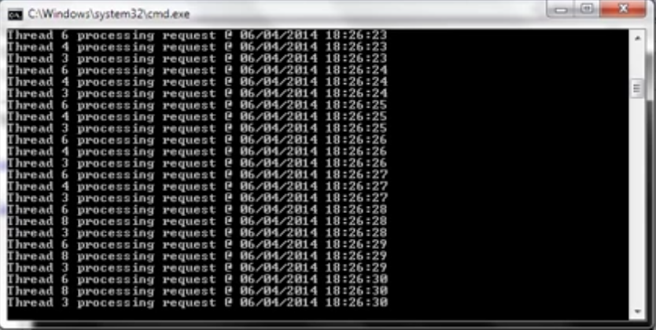

Now notice that only 3 concurrent calls are processed each second. This is because we have specified the max concurrent calls settings in our config file.

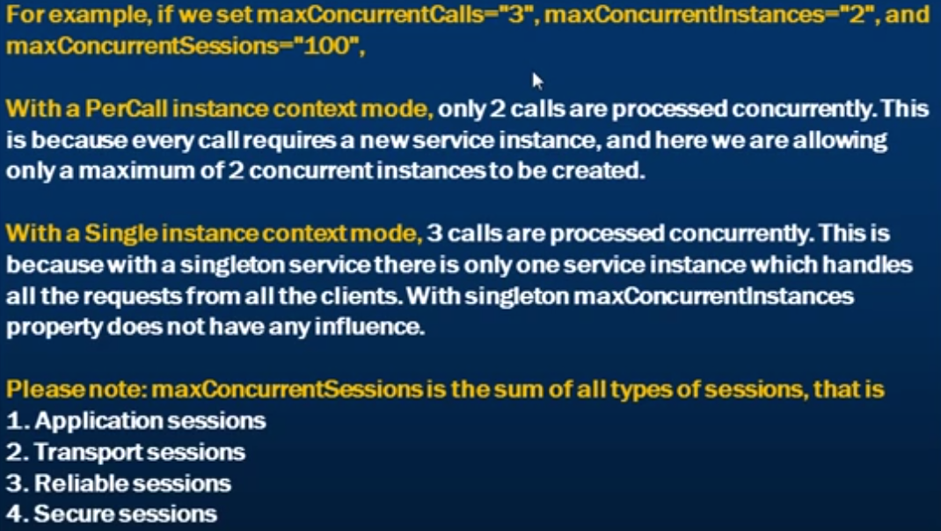

The default throttling settings are

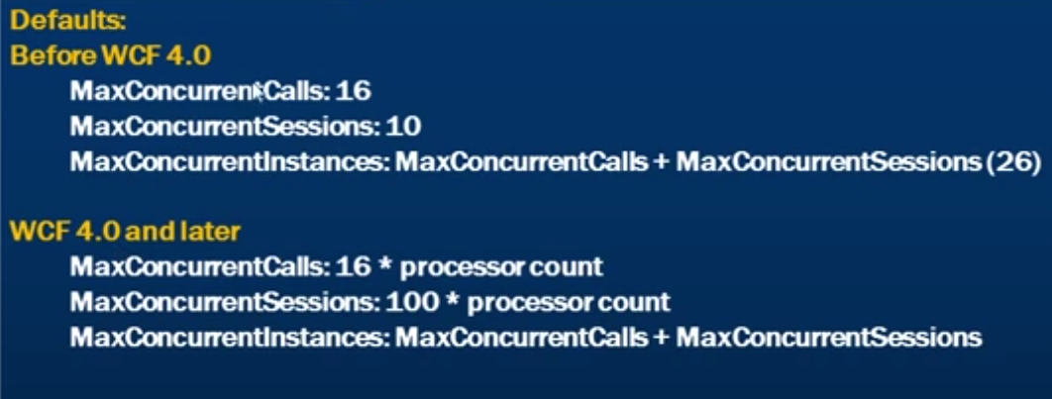

# WCF Security

## Basics of Security

**Authentication ->** the process of identifying the sender and the recipient of the message.

**Authorization ->** the process of determining what right the authenticated user has.

**Confidentiality ->** the process of ensuring that only the intended recipient of the message can view the message as it is being transmitted from the sender to the receiver. We achieve confidentiality by encrypting the message.

**Integrity ->** the process of ensuring that the message is not tempered with by a malicious user as it is being transmitted from the sender to the receiver. We achieve integrity by signing the messages.

Out of the box in WCF, most of the bindings with one exception of basicHttpBinding all of these security features.

The basicHttpBinding is the only binding which does not provide any of the security features by default.

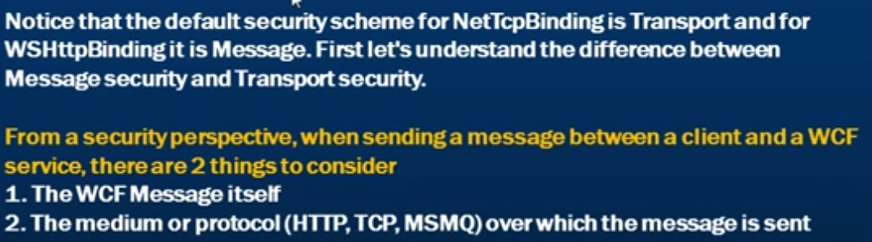

**Transport Security ->** Securing the transport channel is call transport security. Each of the protocols (HTTP,TCP,MSMQ) have heir own way of providing transport security.

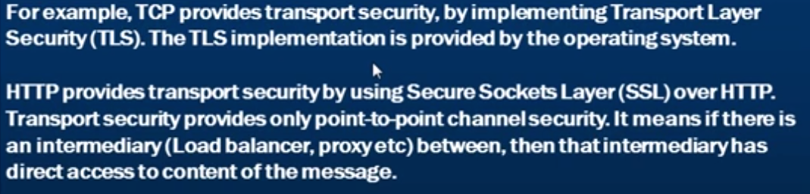

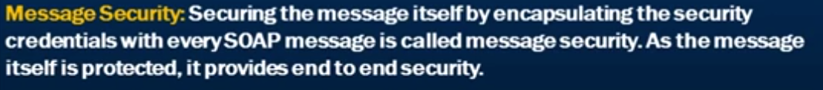

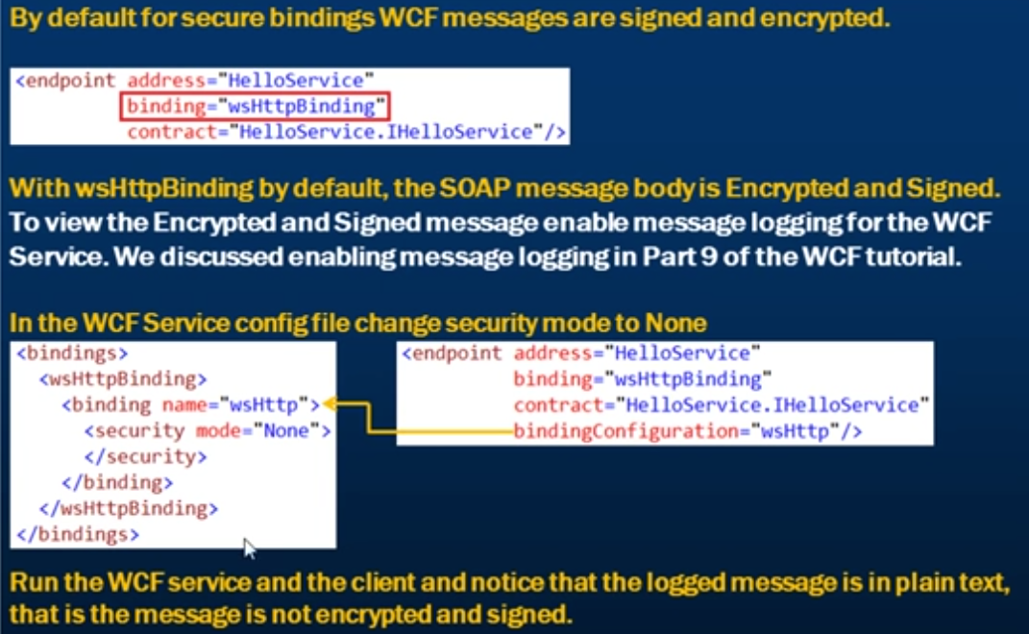

## Message Protection – using protection level parameter

If we want to customize the level of protection of the messages in WCF, we can use the protection level.

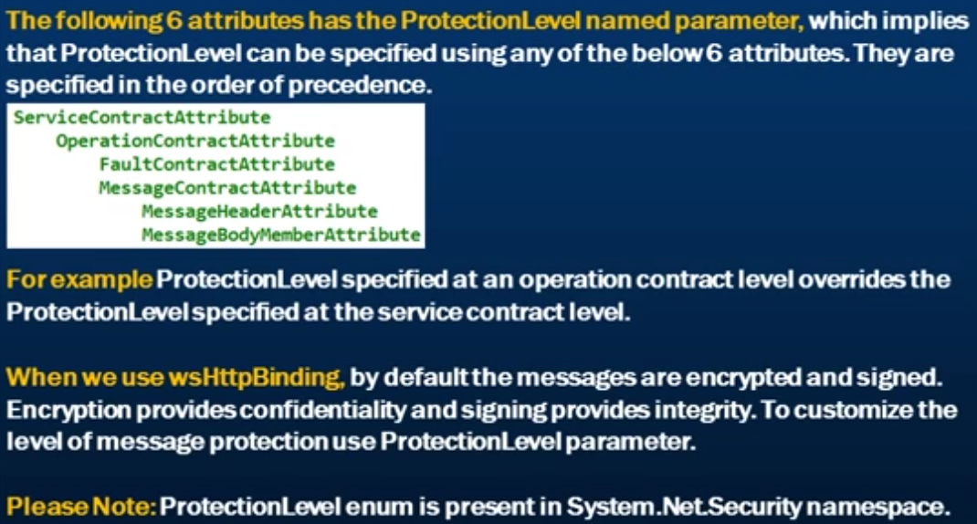

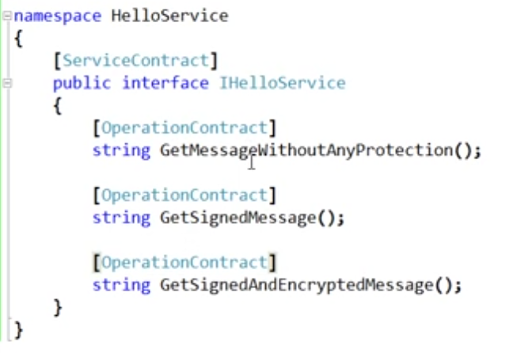

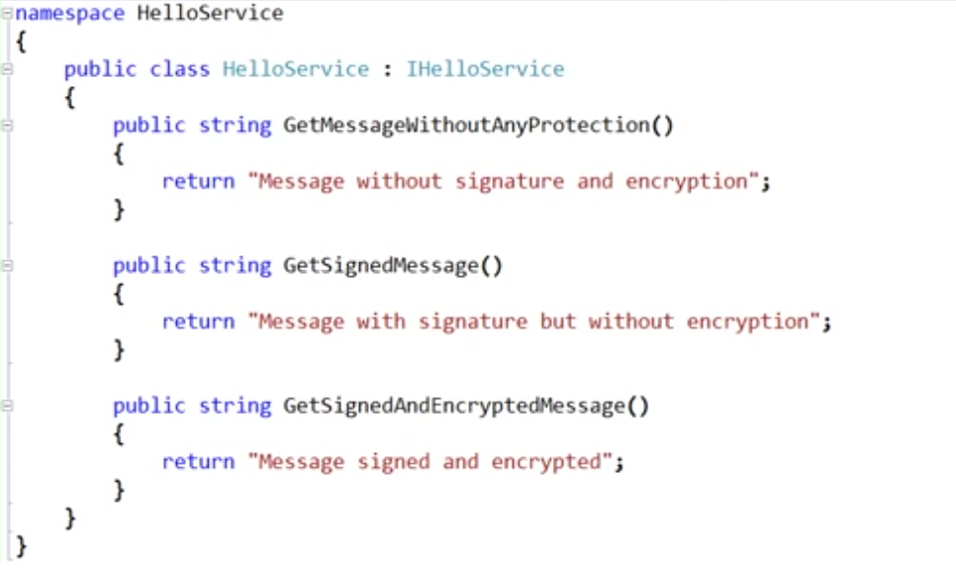

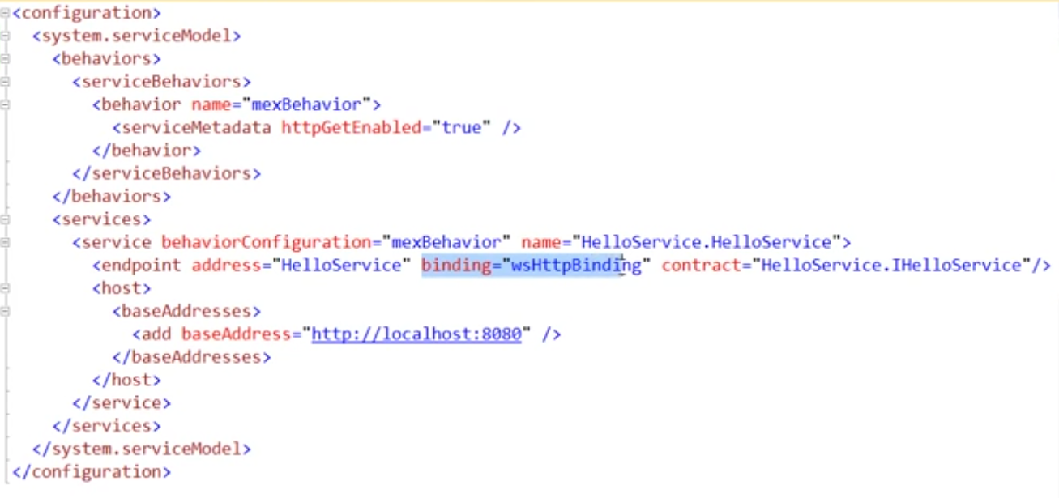

We are using the defaults of the wsHttpBinding. Be default it is going to encrypt and digitally sign all the messages.

Now changing the service contract to below

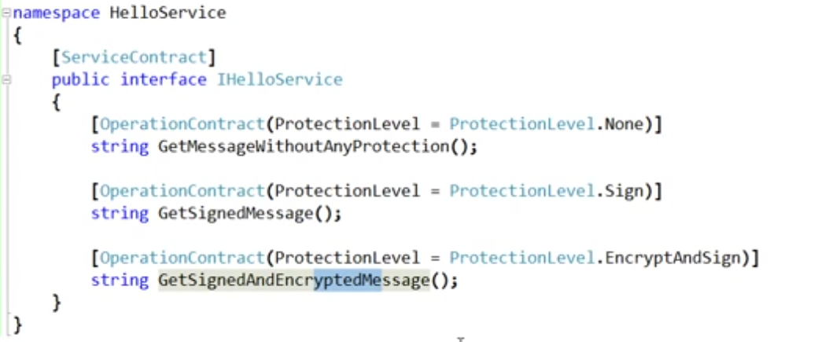

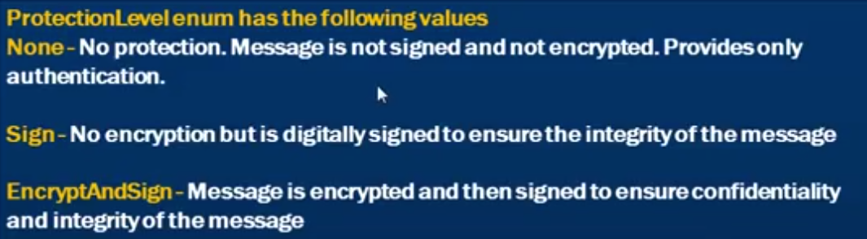

## WCF Bindings and their impact on Message Protection

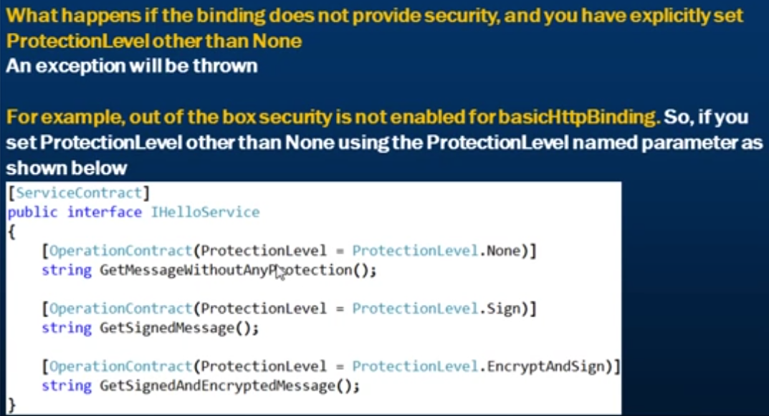

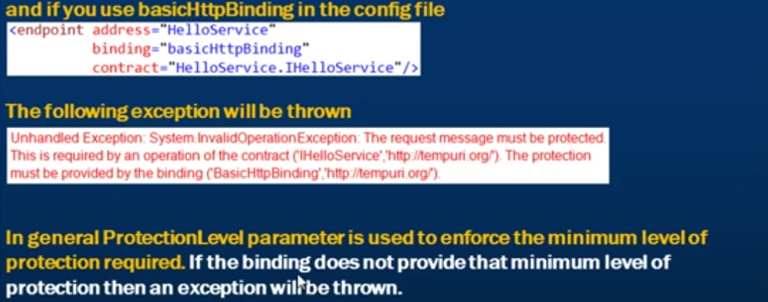

## Authentication in WCF

Out of the box, most bindings provide authentication without any additional configuration in WCF.

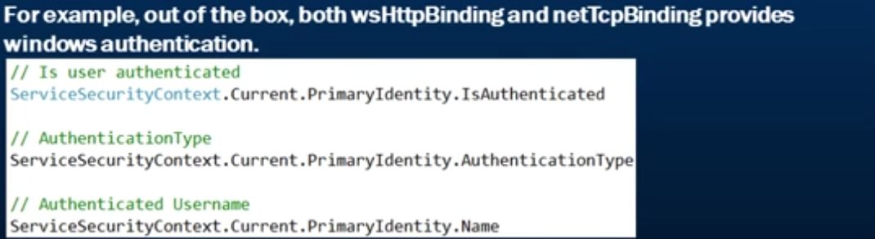

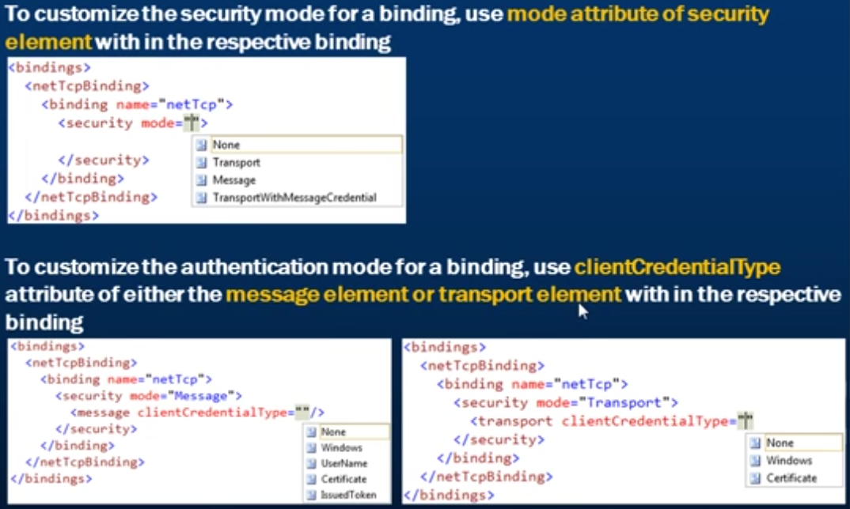

## Transport Security in WCF

Message confidentiality and integrity with transport security.

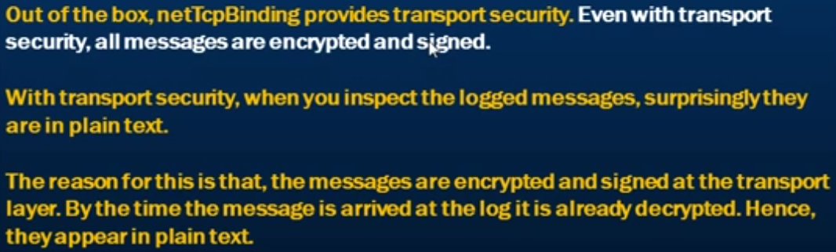

## Configure wsHttpBinding to use Transport Security and basic client credential type.

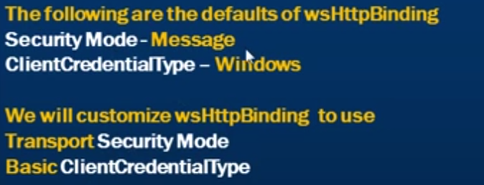

To change the security mode from Message to Transport, we need to issue/create a SSL certificate. We can do this through IIS..

Click on the IIS root at the left and then from the features, select Server Certificates. Once you double click and open Server Certificates, you can see an option on the right of the window for “Create Self-signed certificate.”

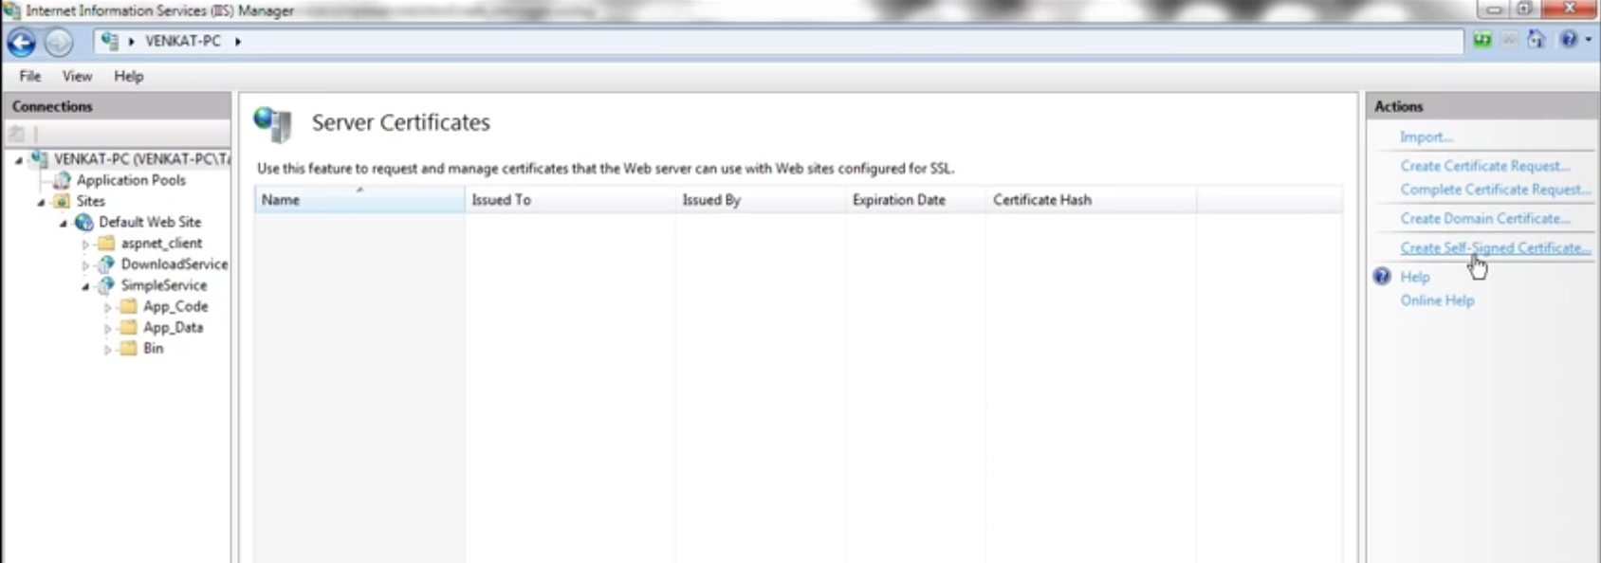

Create one certificate.

Now click on Default Web Site and click Bindings on the right side panel to see the bindings.

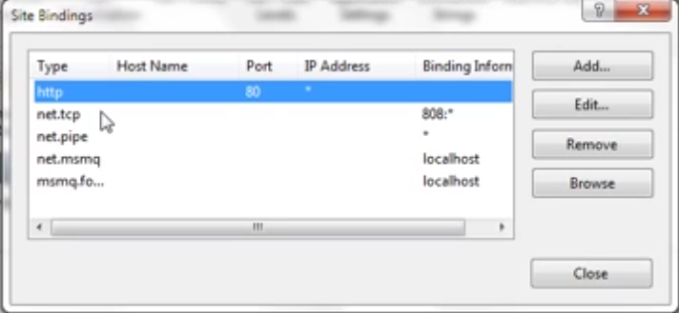

If we want to use the transport security with wshttp binding then we are going to need SSL over http. This means that apart from http, we also need https binding.

Click Add and fill the details for https bindings.

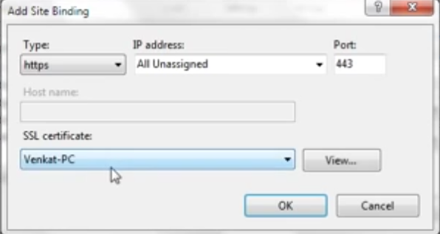

Venket-PC is the name of the self-signed certificate created.

Now click on your web site and select the feature SSL Settings.

Trun on the Require SSL and choode accept for client certificates.

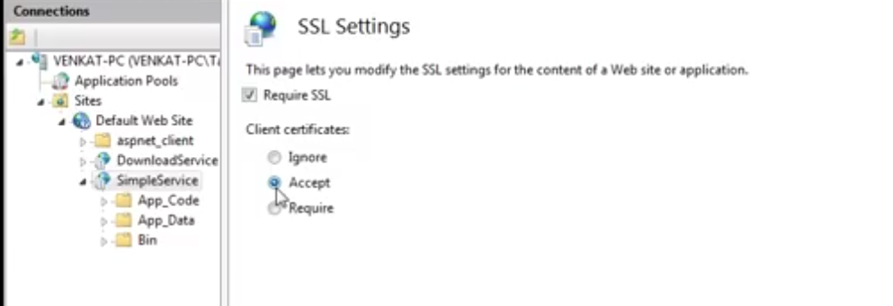

Notice that we have selected the SimpleService Website. Apply the changes.

Include the following configuration in the Web,config

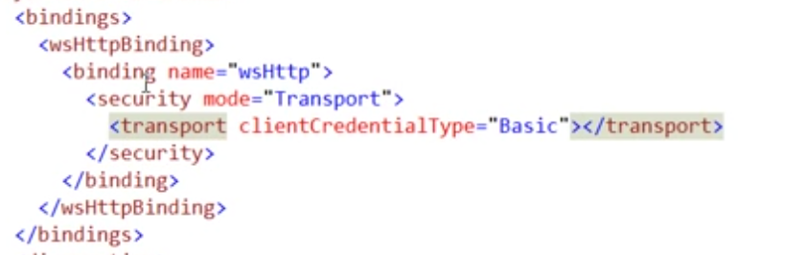

Lastly, select the web site in IIS and click the feature Authentication.

Turn on the Basic Authentication.

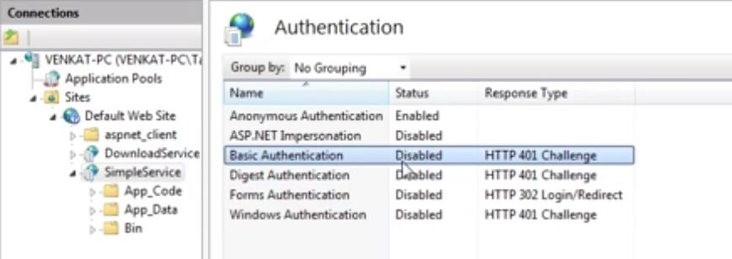

In the mexBehaviour, change the httpGetEnabled = true to httpsGetEnabled to true.

While creating a client for the WCF Service and adding the service reference, since we have created a SSL certificate for our service,

The service reference url must take the name of the certificate instead of localhost now.

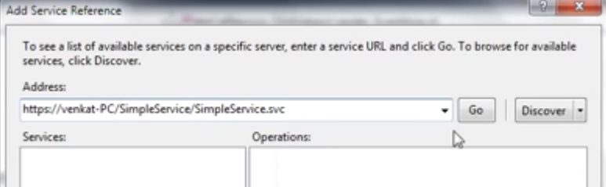

Finally, in the client application, we need to provide the client credentials before calling the service

## Configure netTcpBinding to use Message Security.

